**Integrate eGit plugin with Eclipse**

<https://www.youtube.com/watch?v=XuuzSaelUzo>

Step 1:

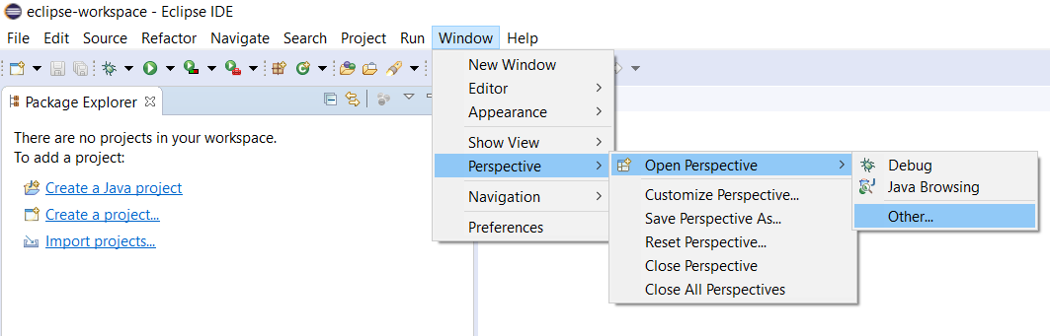

Step 2:

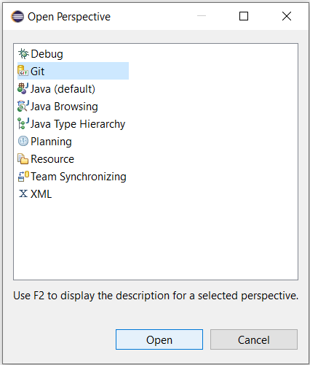

Step 3: Select Java Perspective

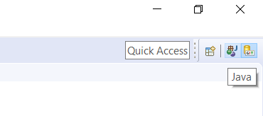

Step 4:

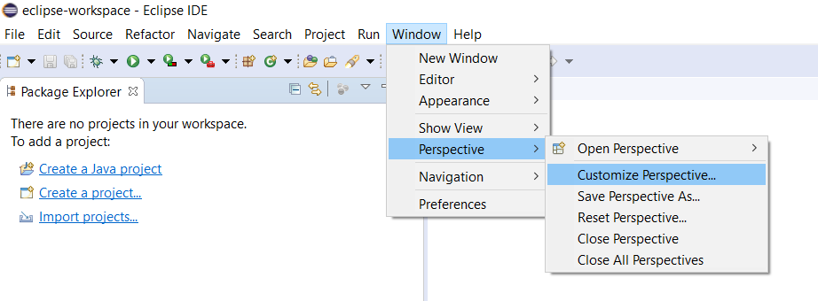

Step 5: Select both Git and Git Navigation Actions from the “Action Set Availability” tab.

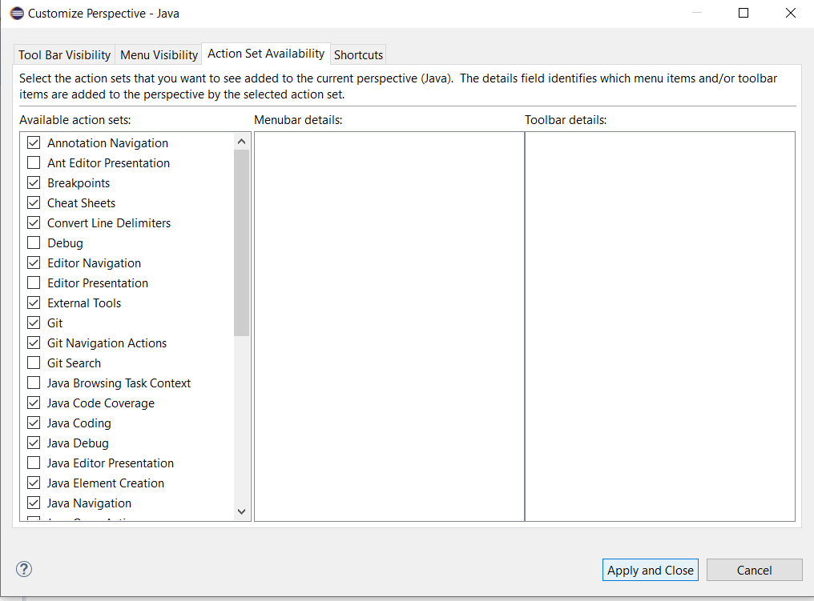

Step 6: Make sure Git and everything under it are selected. Select “Apply and Close” button

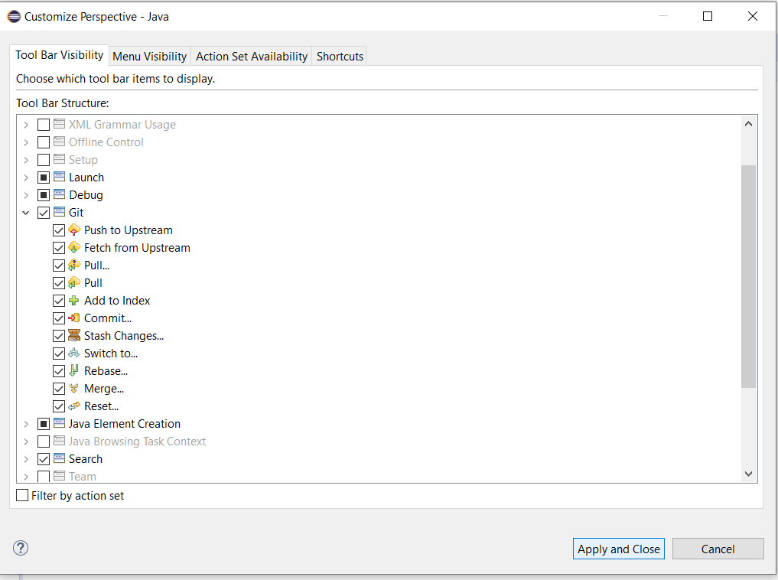

Step 7: Make sure the Java perspective is selected first.

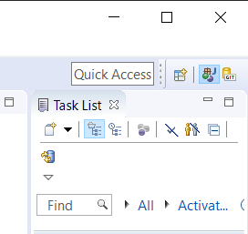

Step 8:

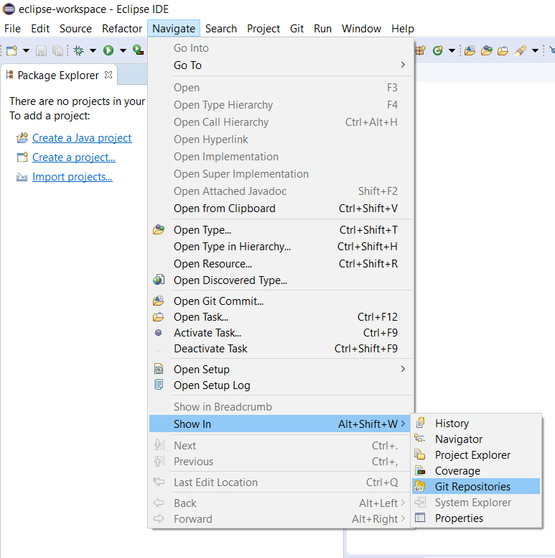

It should look like this.

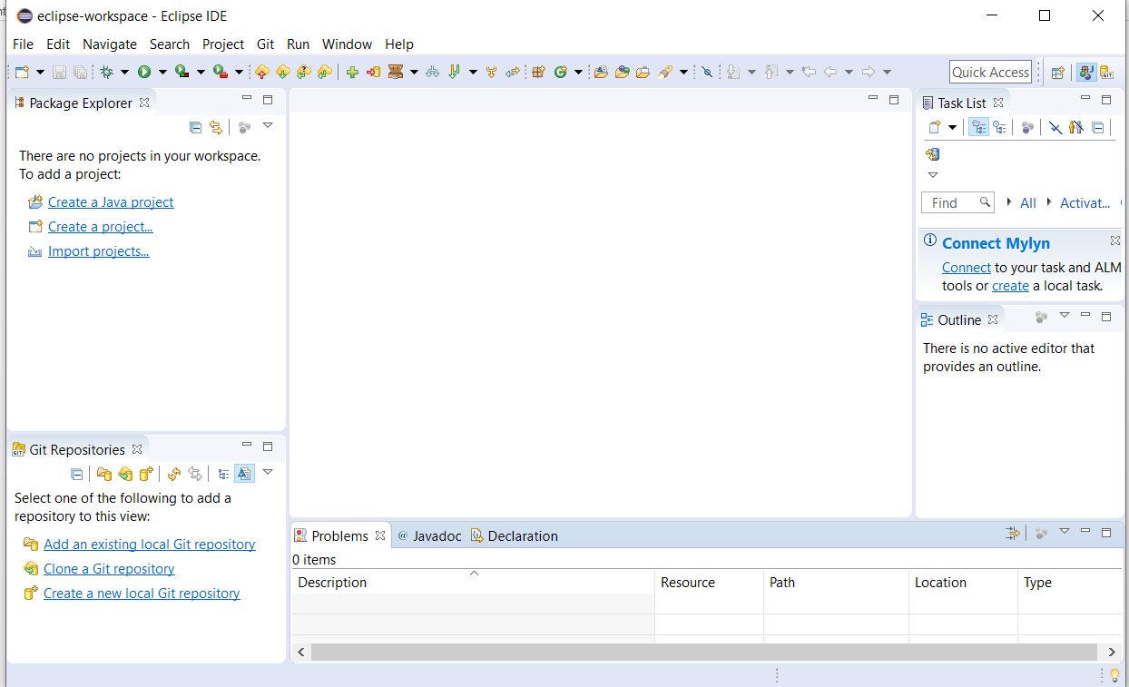

**Create an Empty Repository from GitHub**

Step 1: Sign it to GitHub.com to create a Repository

Step 2: This image shows I already signed in. I Just need to select the New button.

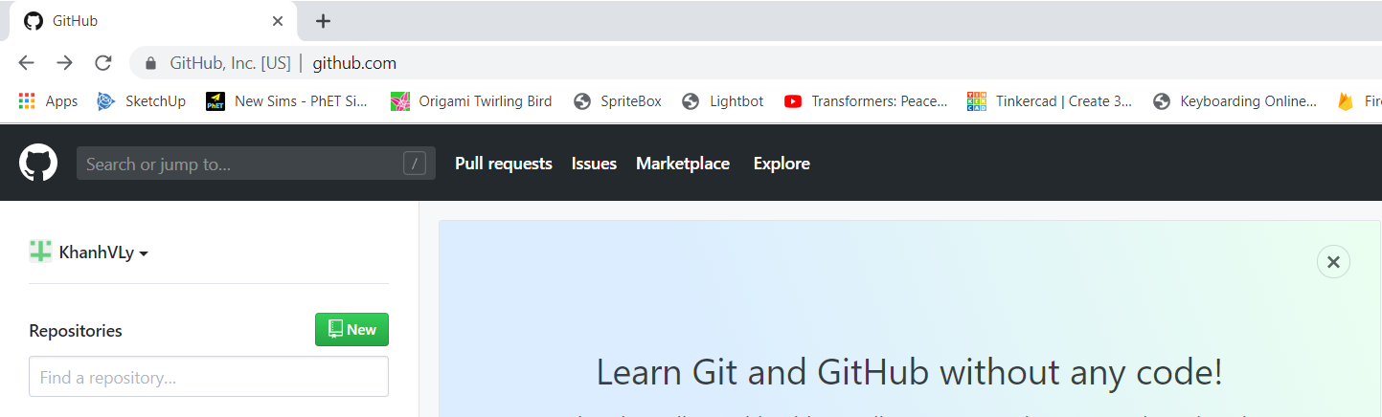

Step 3:

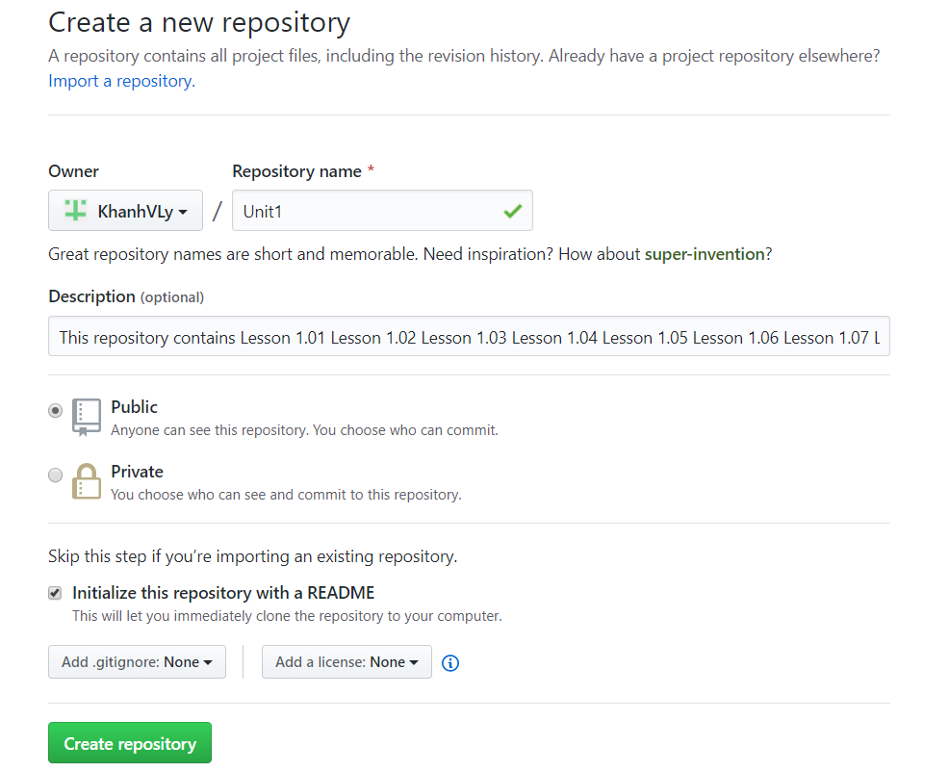

This is what you should have.

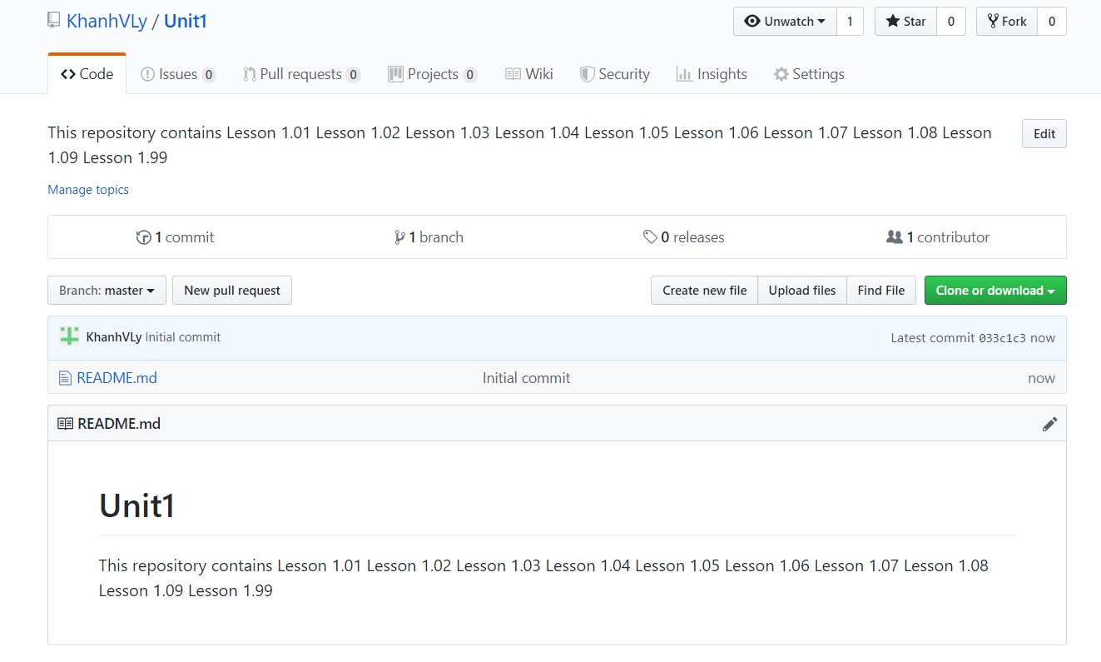

**Clone an empty GitHub repository from Eclipse**

Step 1: select the “Clone or Download” button and copy the url.

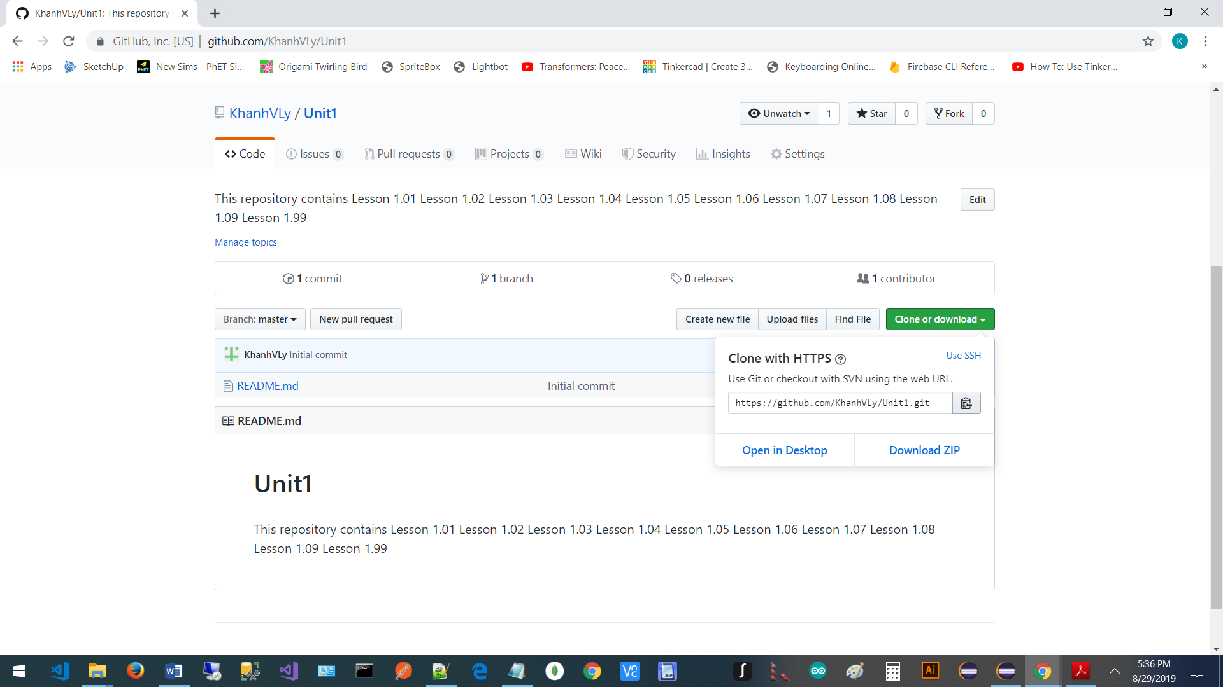

Step 2: Open the Eclipse

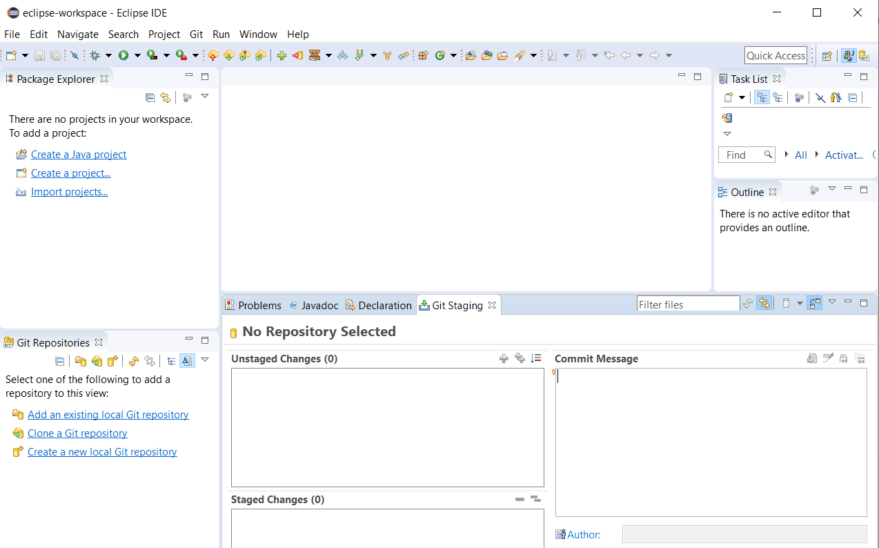

Step 3: Make sure the Java perspective is selected first.



Step 4: Select the “Clone a Git repository” button.

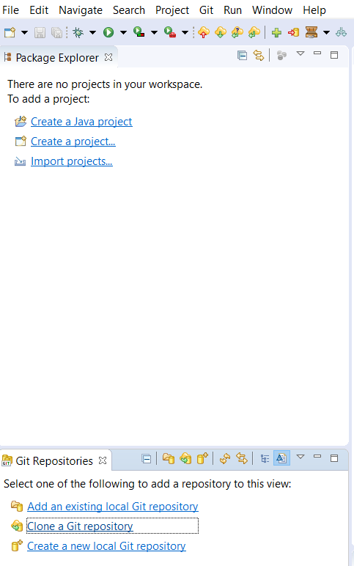

Step 4: Replace my info with your info in all the text boxes by pasting the url you copied from step 1 and enter your user id and password.

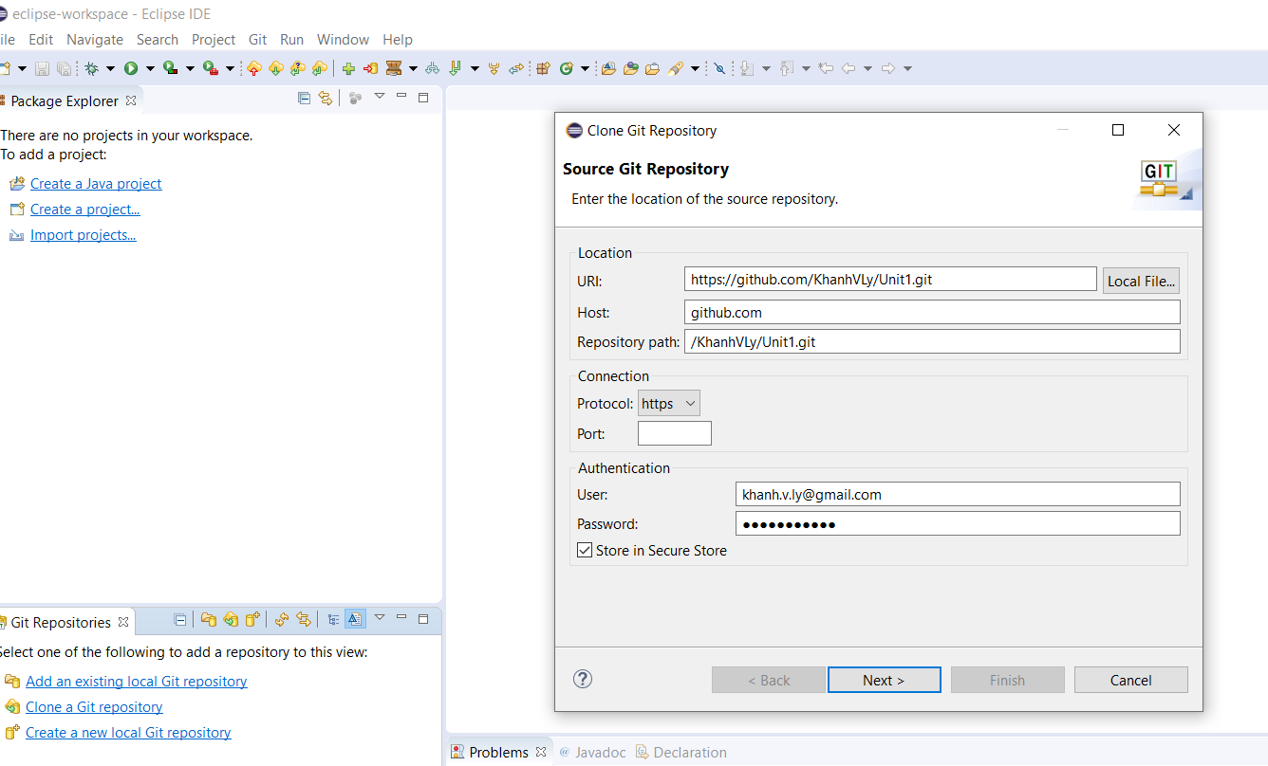

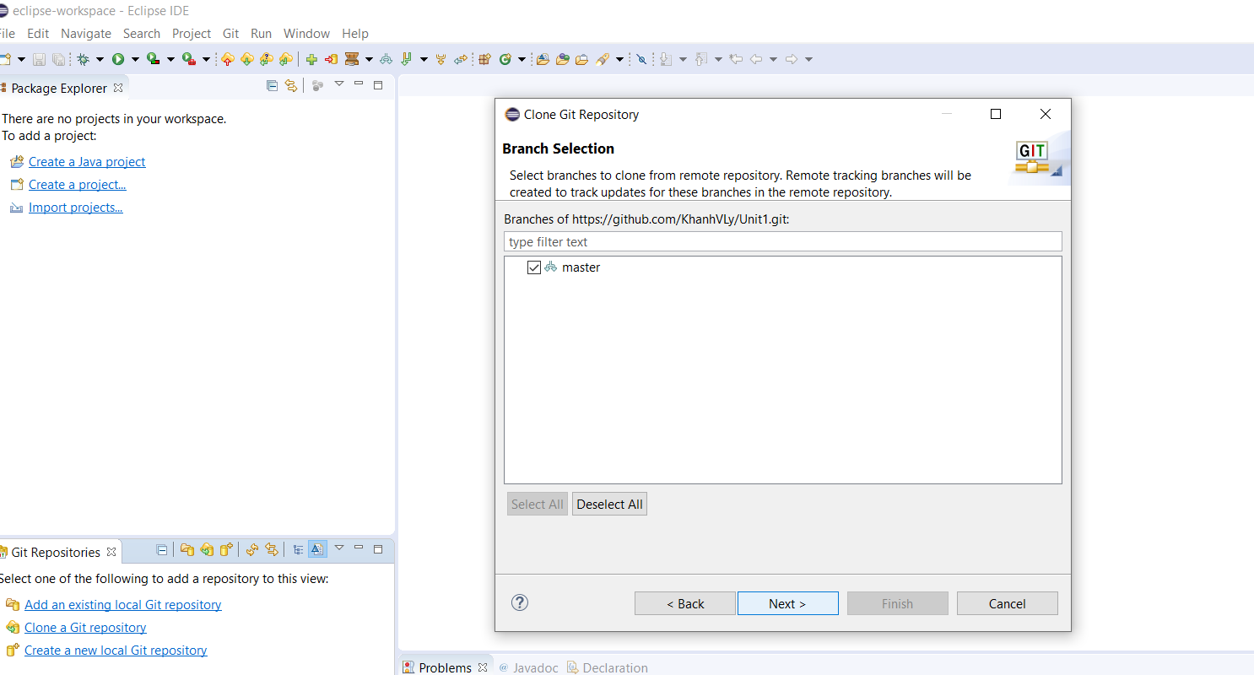

Step 5: Change the directory name your directory name.

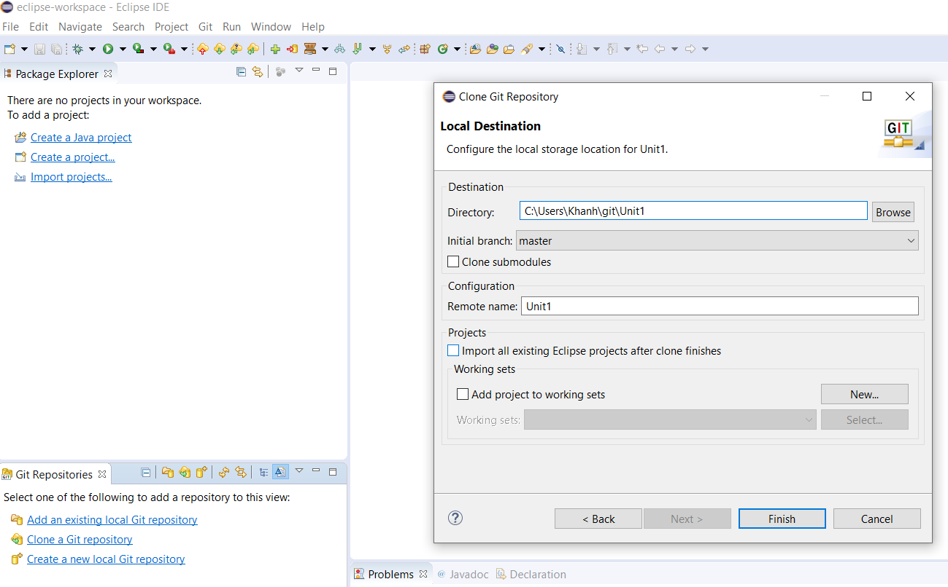

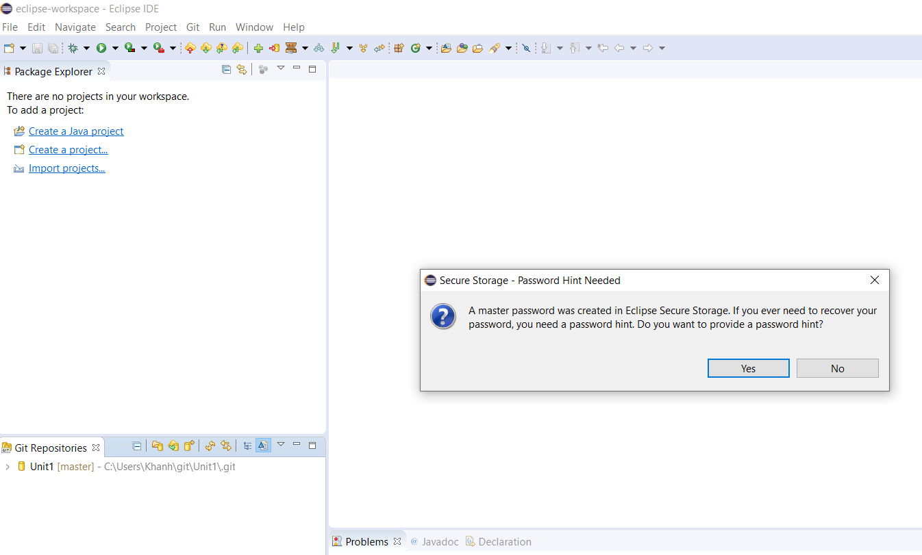

It should look like this.

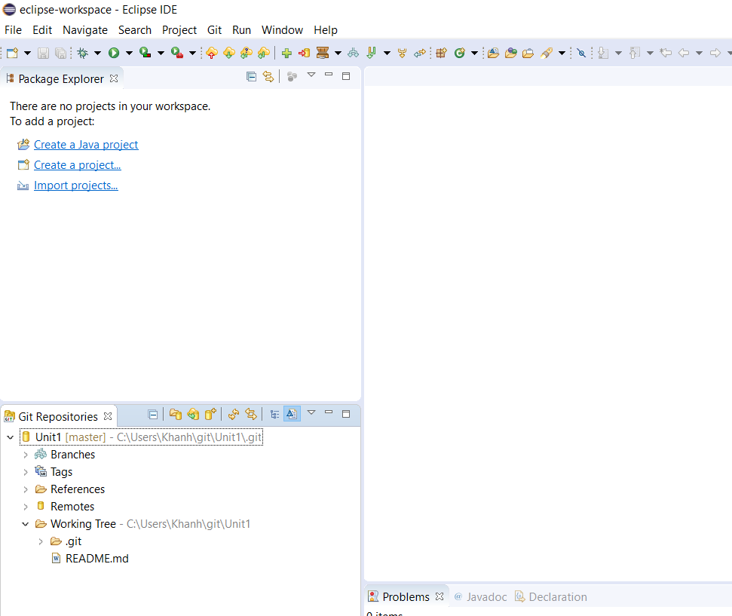

**Add Lesson1.01 Java project in Eclipse**

Step 1:

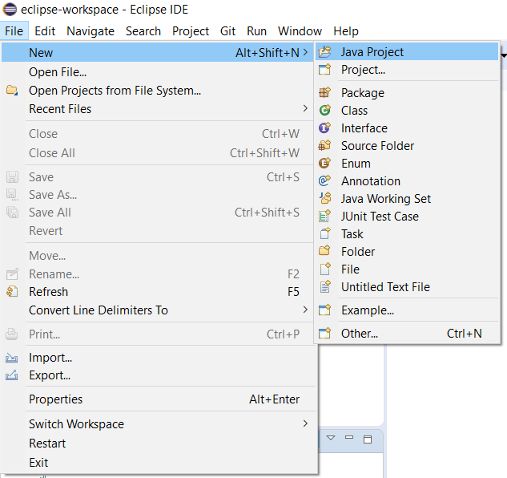

Step 2:

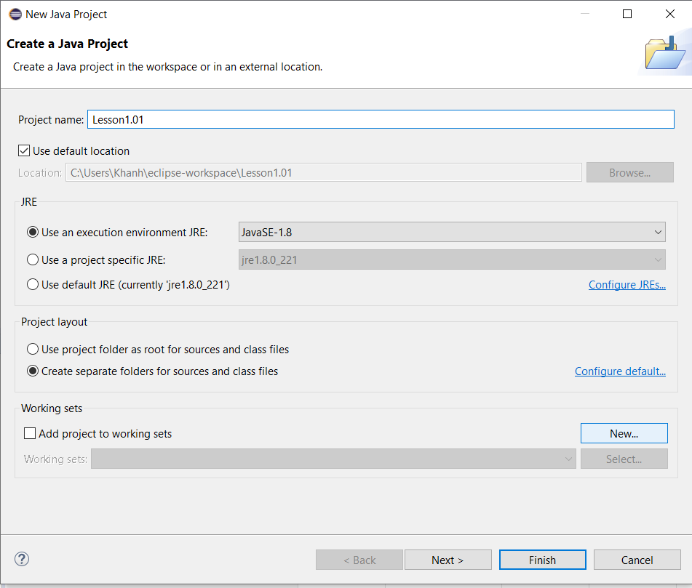

Step 3: Right-click the src folder.

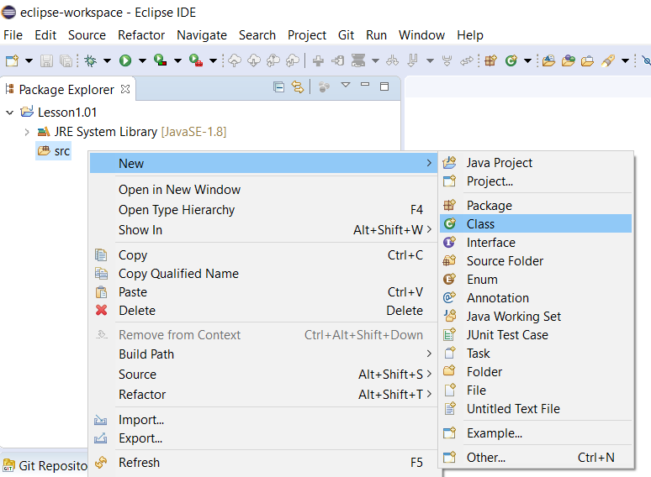

Step 4:

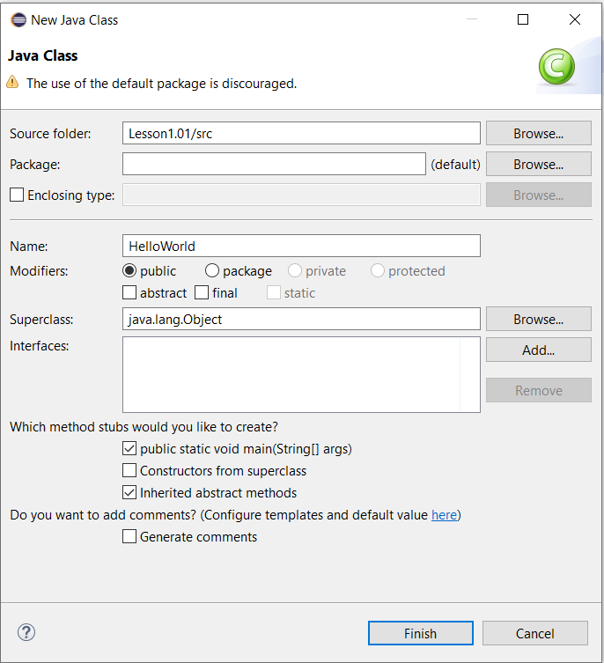

It should look like this.

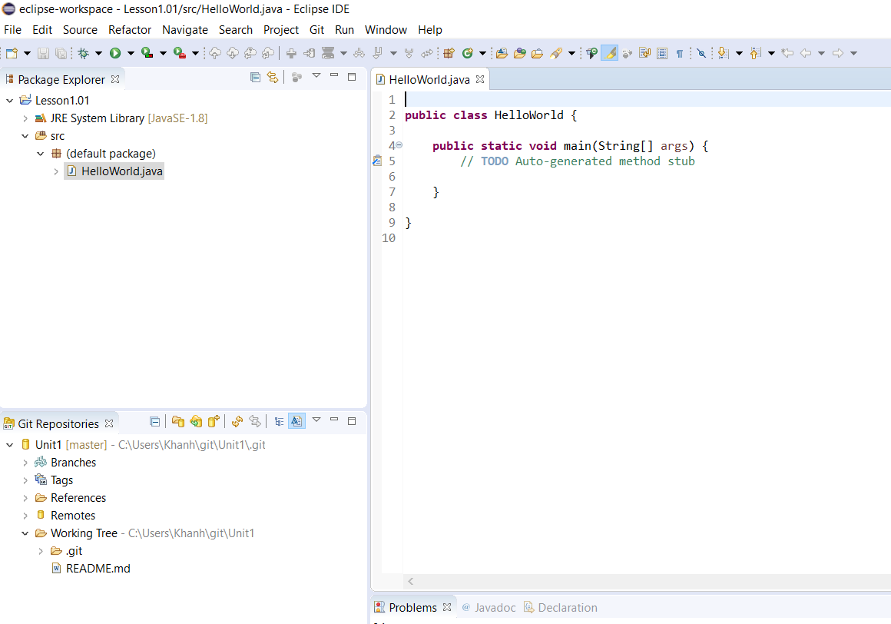

**Add Lesson1.01 Java Project to Unit1 Repository in Eclipse**

Step 1: Select Lesson1.01 folder and right-click

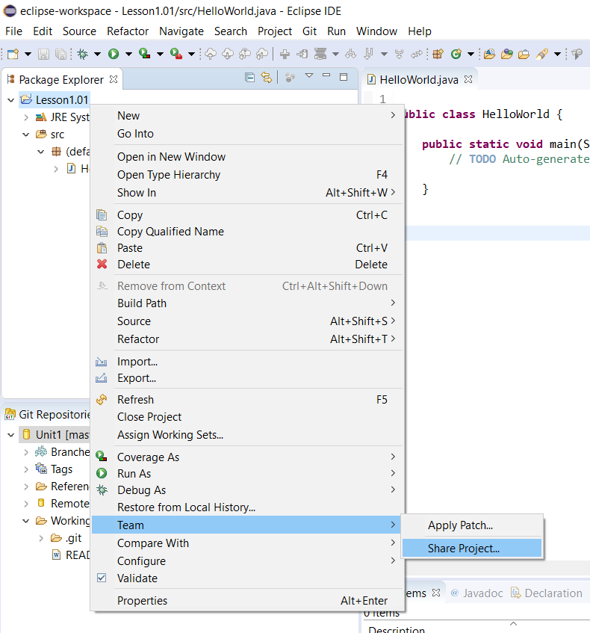

Step 2:

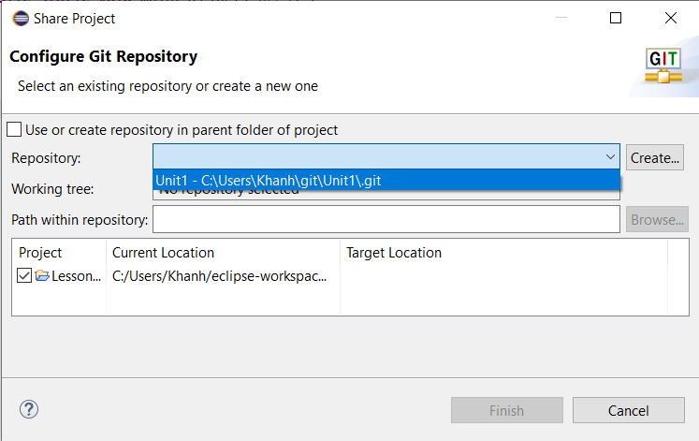

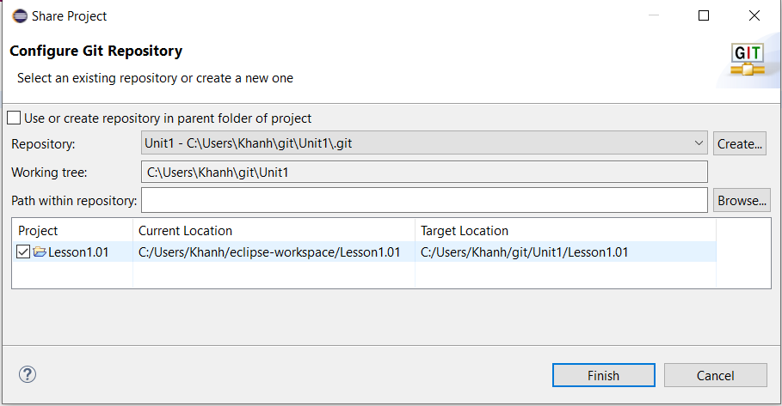

**Commit and Push Lesson1.01 Java Project from Eclipse to GitHub under Unit1 Repository**

Step 1: Select Lesson1.01 folder and right-click

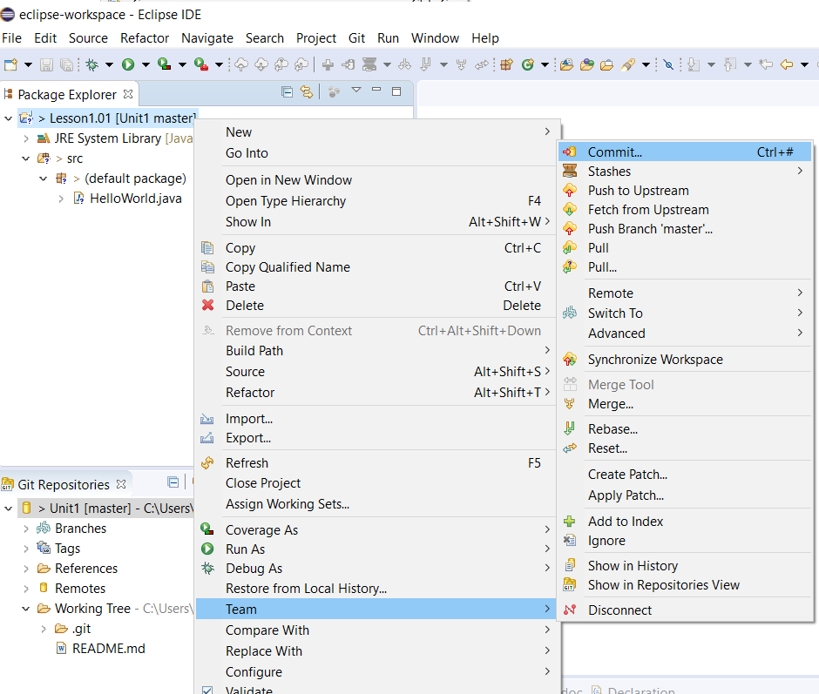

Step 2: select the double plus sign icon under the Unstaged Changes section and enter some text in the Commit Message box.

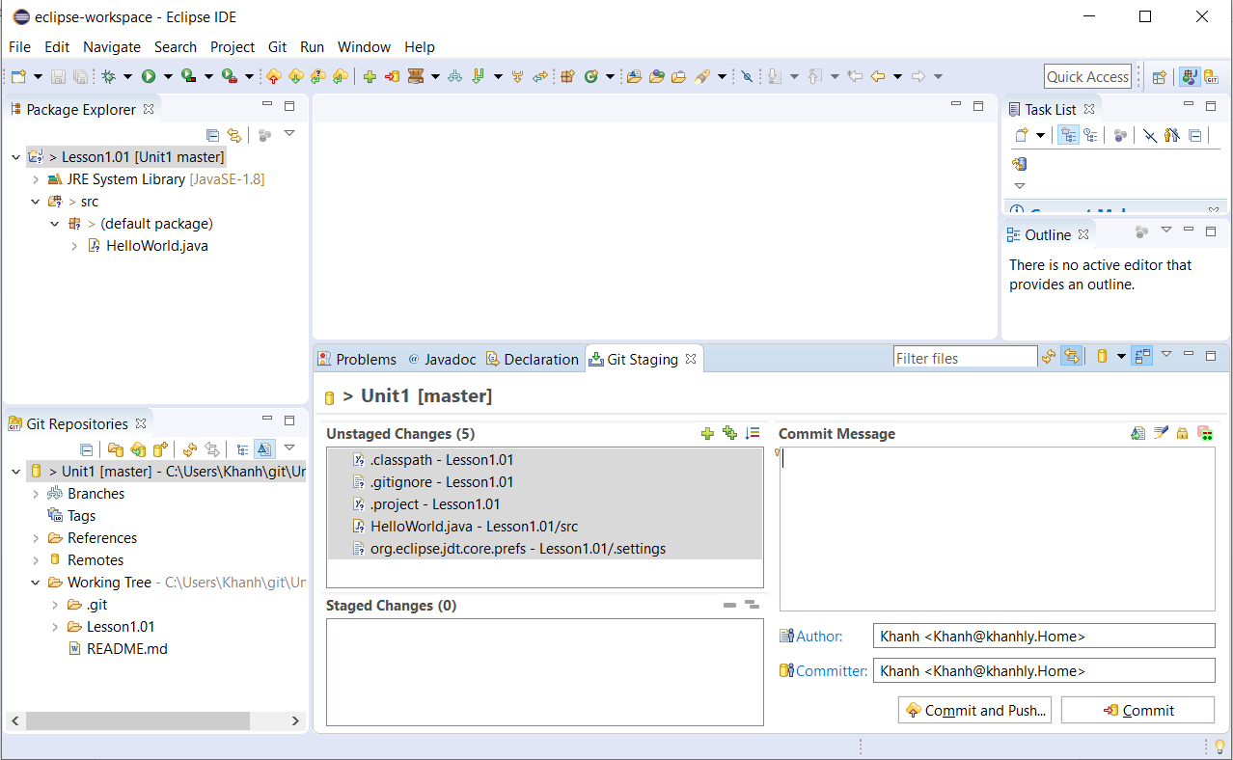

Click on Commit and Push… button

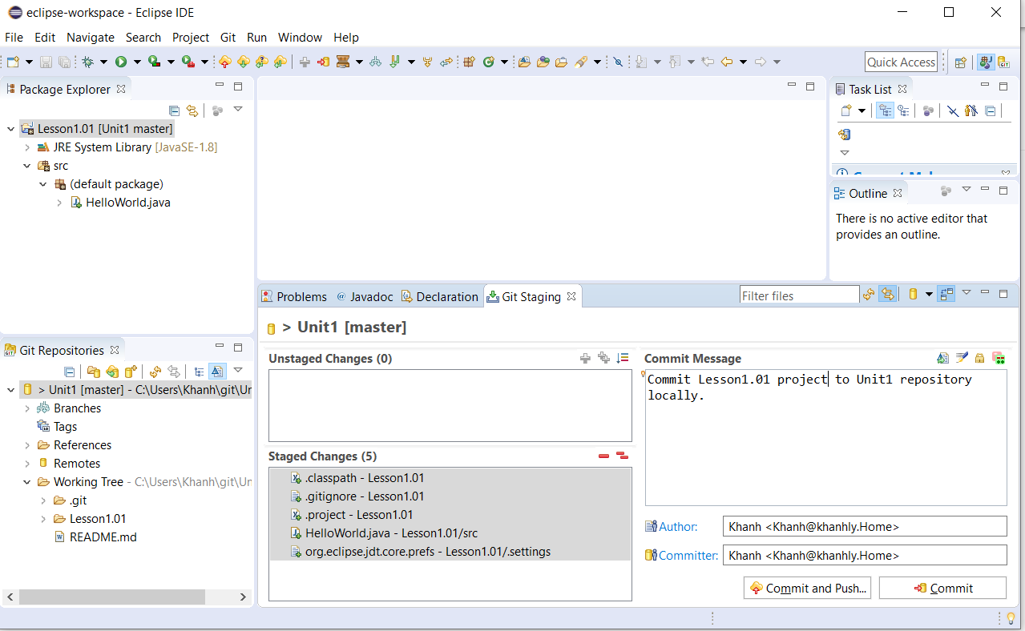

Step 3: Click the Close button.

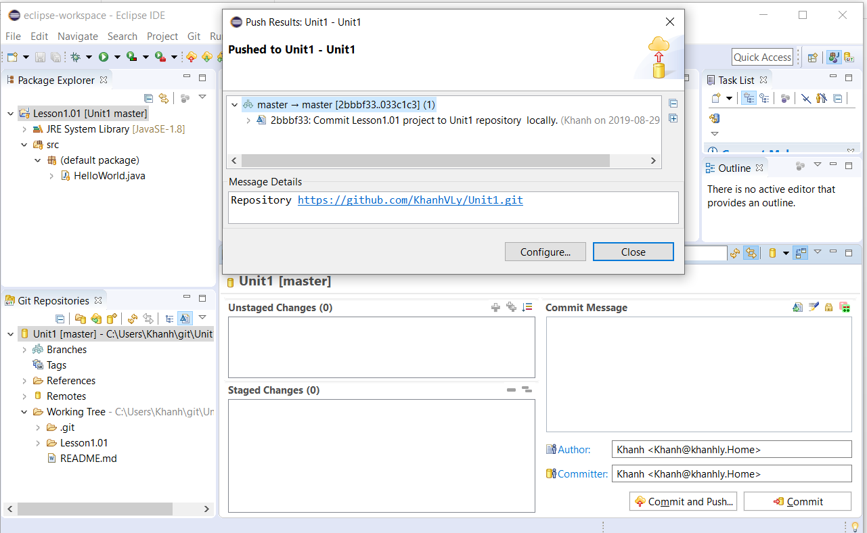

Step 4: Sign into GitHub again to see [Lesson1.01](https://github.com/KhanhVLy/Unit1/tree/master/Lesson1.01) project under Unit1 repository. Something like this.

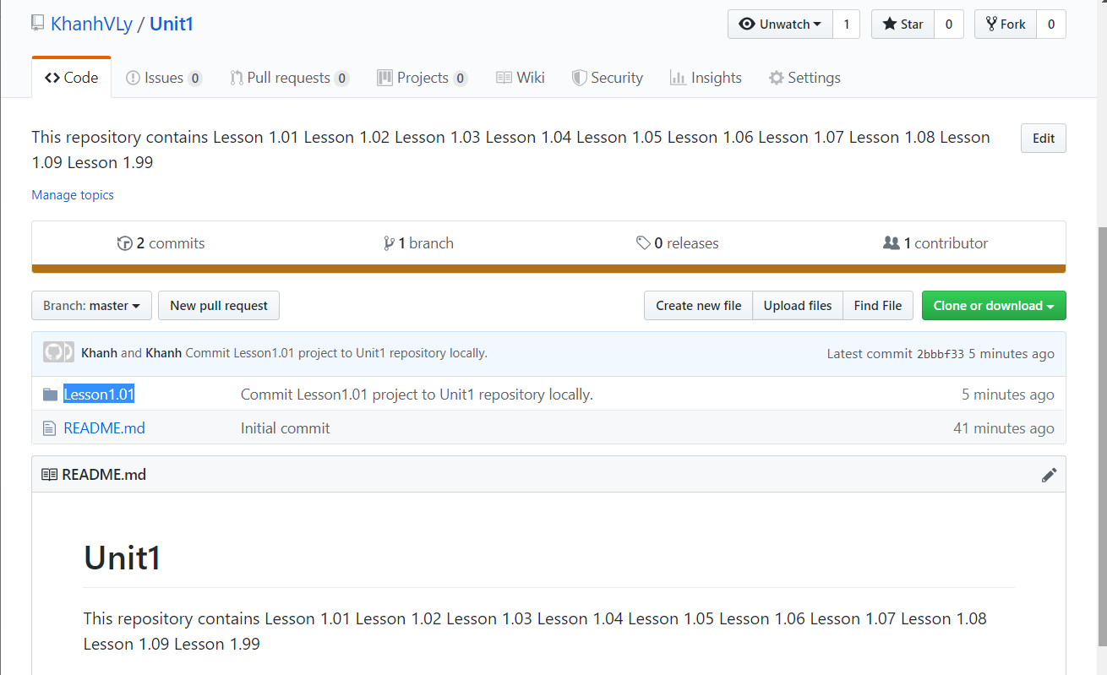

**Add another java file to Lesson1.01 project in Eclipse and push it to GitHub under Unit1 Repository**

Step 1: Right-click Lesson1.01 folder

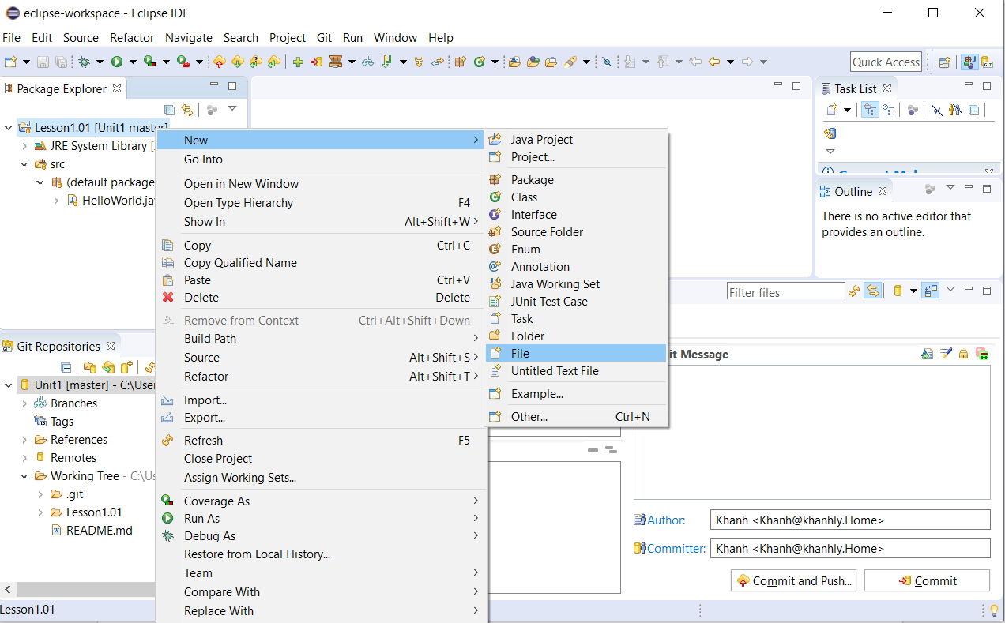

Step 2:

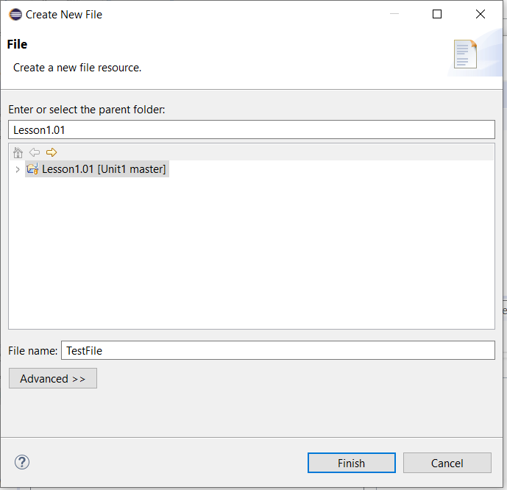

Step 3: Right-click the TestFile

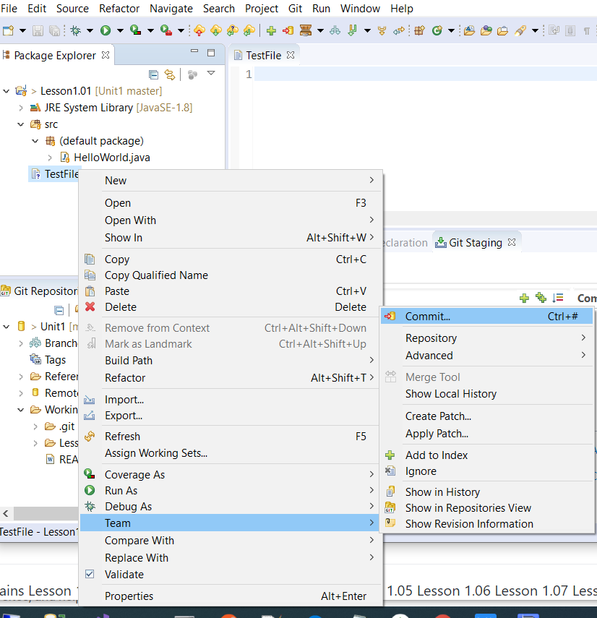

Step 4: Enter some text in the Commit Message box.

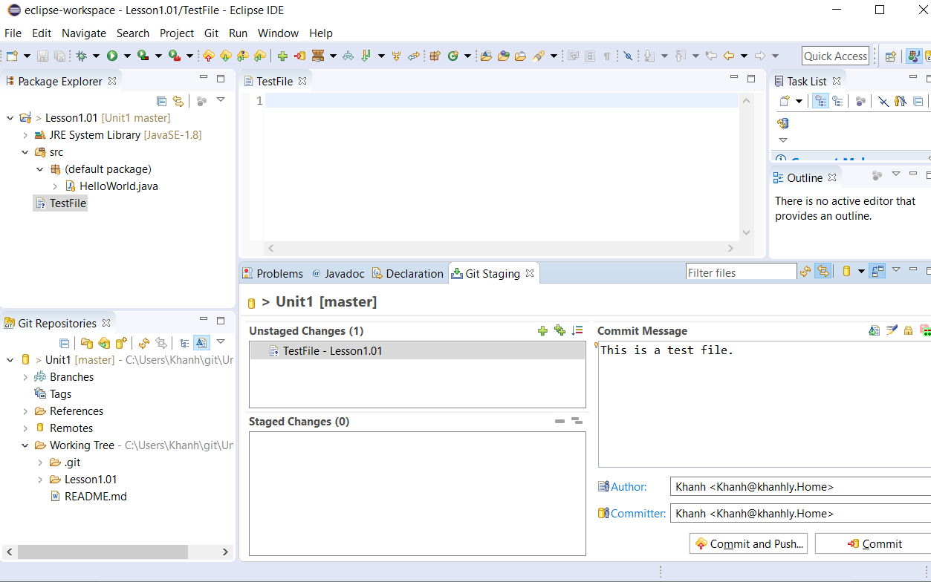

Step 5: Select the double plus sign icon from the Unstaged Changes section to add the TestFile to the Staged Changes section.

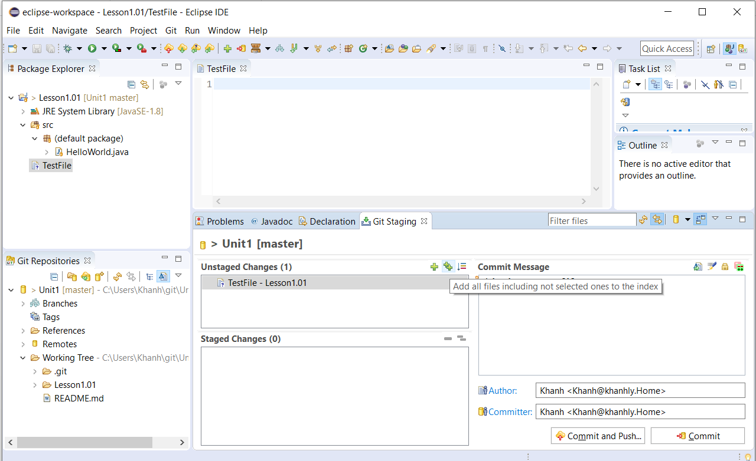

Step 6: Click on the “Commit and Push…” button.

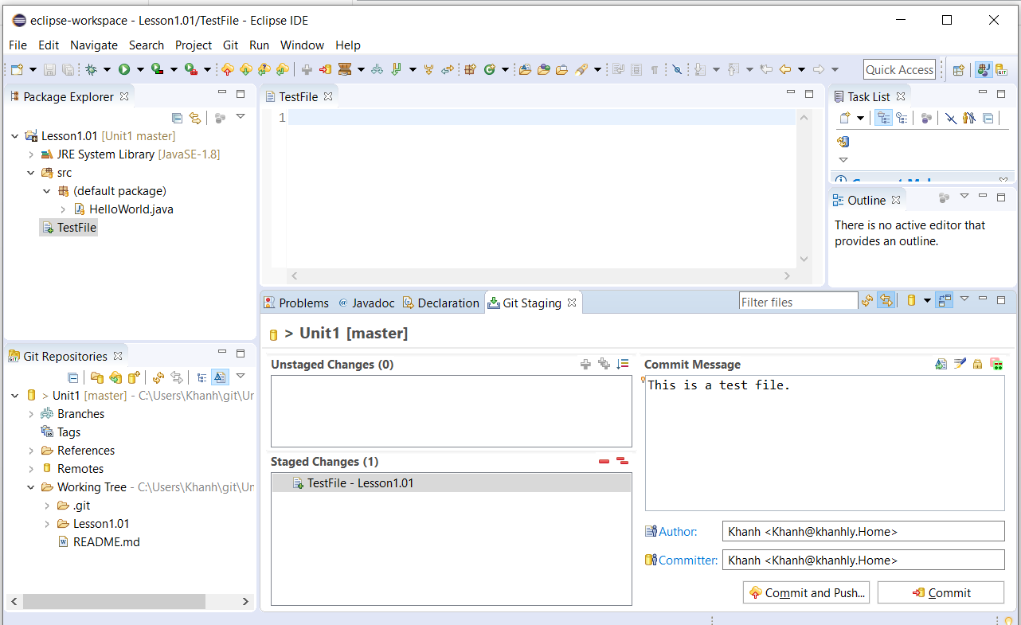

Step 7:

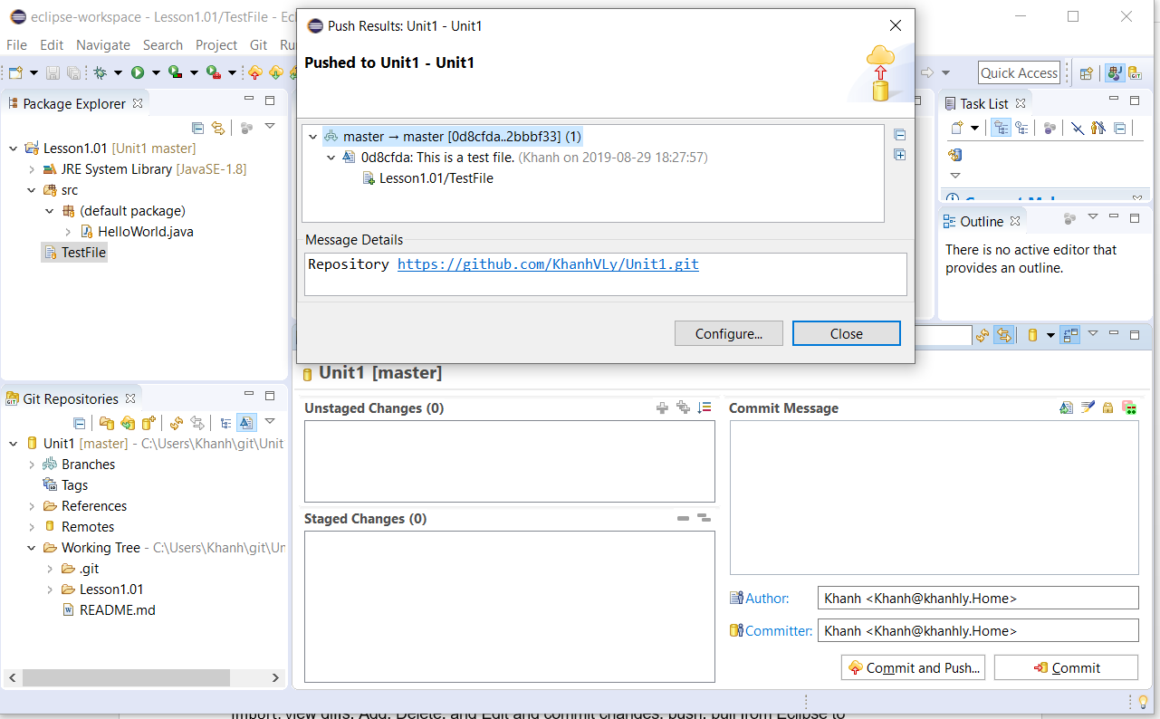

It should look like this from GitHub under Unit1 repository.

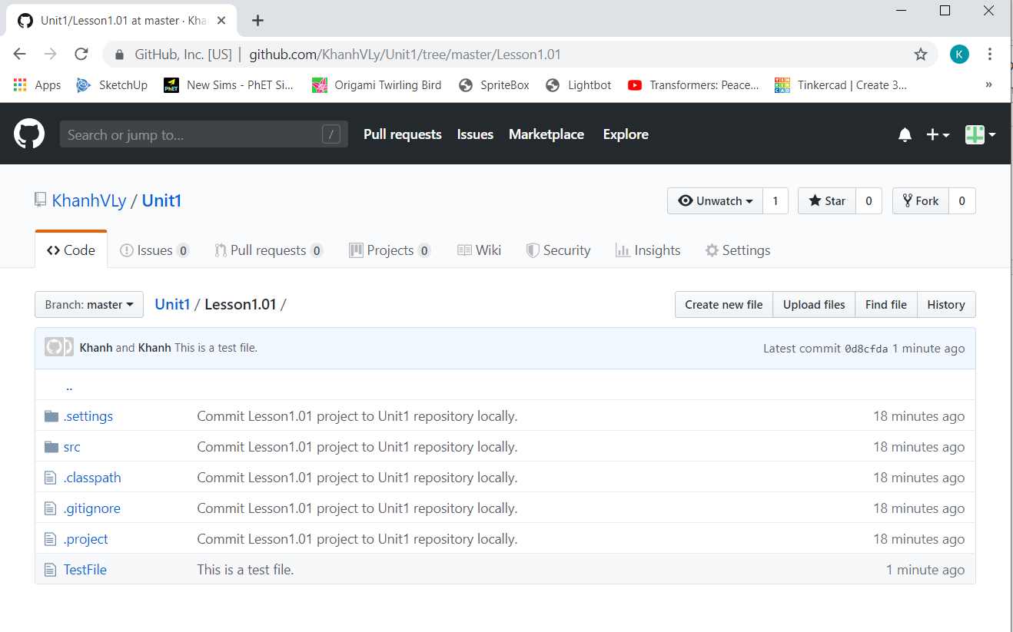

**Add some text to the TestFile in Eclipse and Push it to GitHub.**

Step 1: Add some text

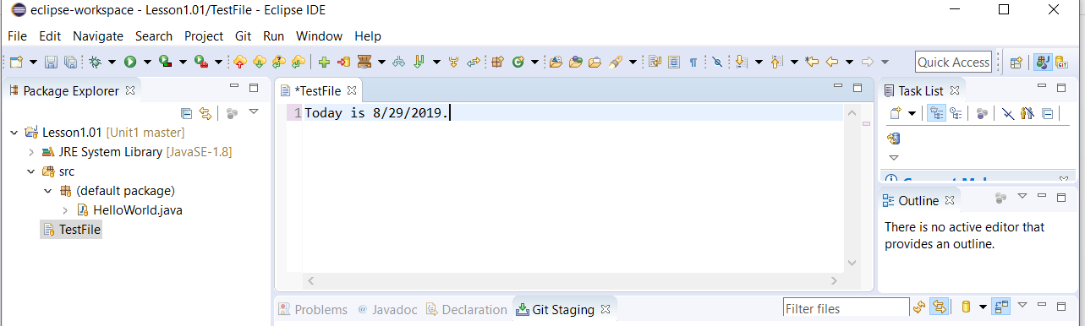

Step 2: Select the Save button

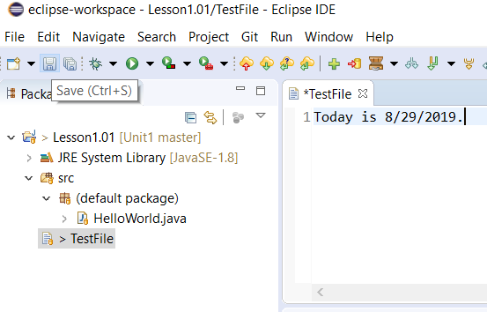

Step 3: Add some text to the Commit Message box and select a single plus sign icon to add the TestFile from the Unstaged Changes section to the Staged Changes section.

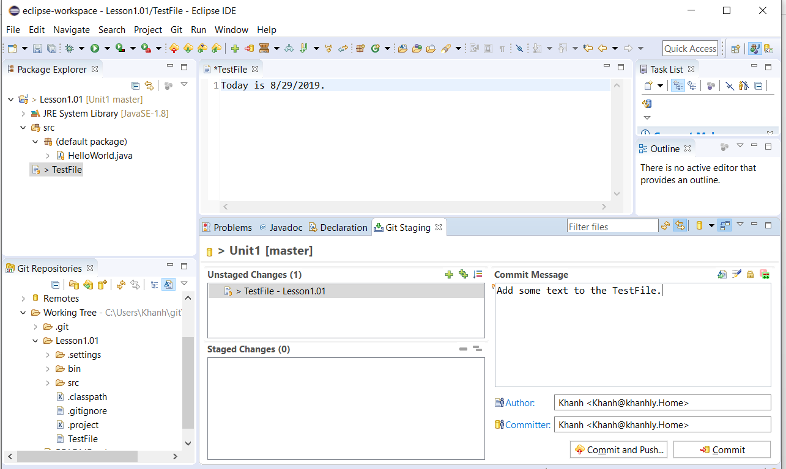

Step 4: Click on the Commit and Push… button

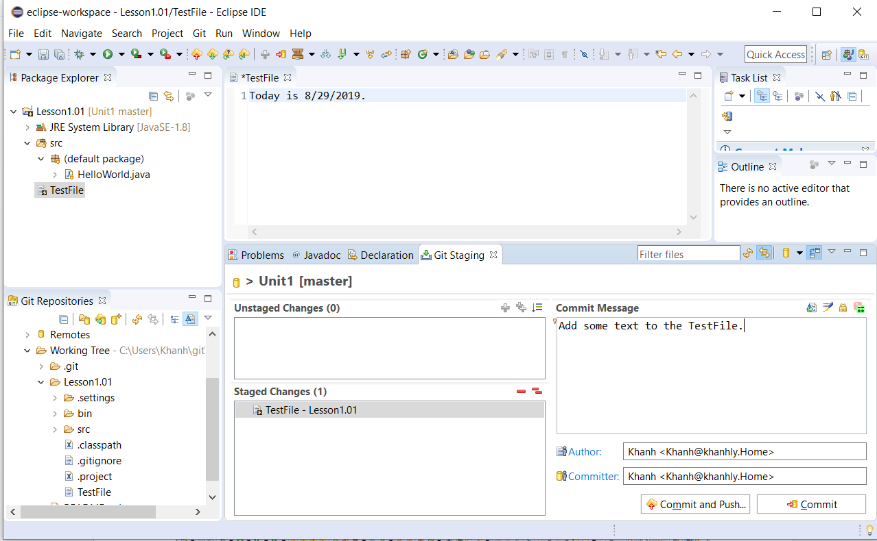

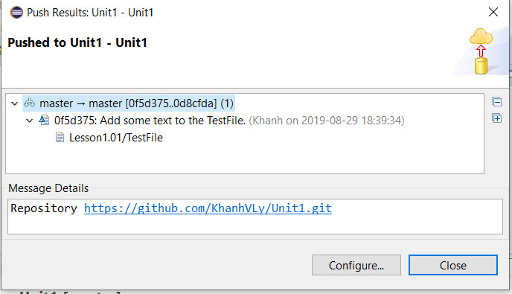

It should look like this from GitHub under Unit1 repository.

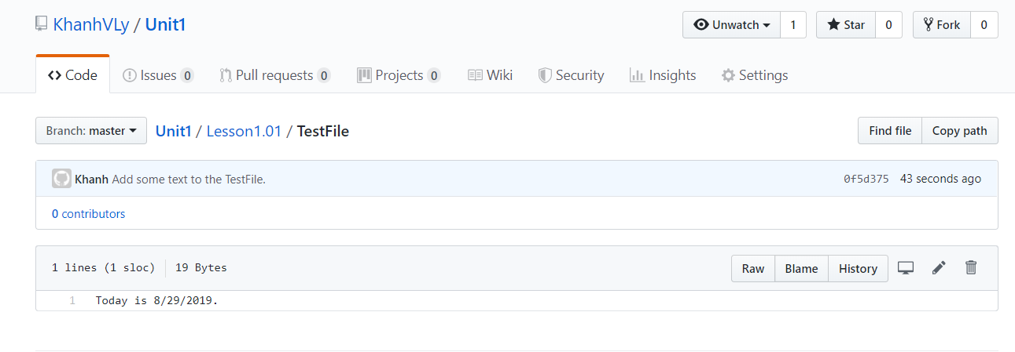

**Delete a file from Eclipse and push it to GitHub**

Step 1: Select the TestFile and right-click

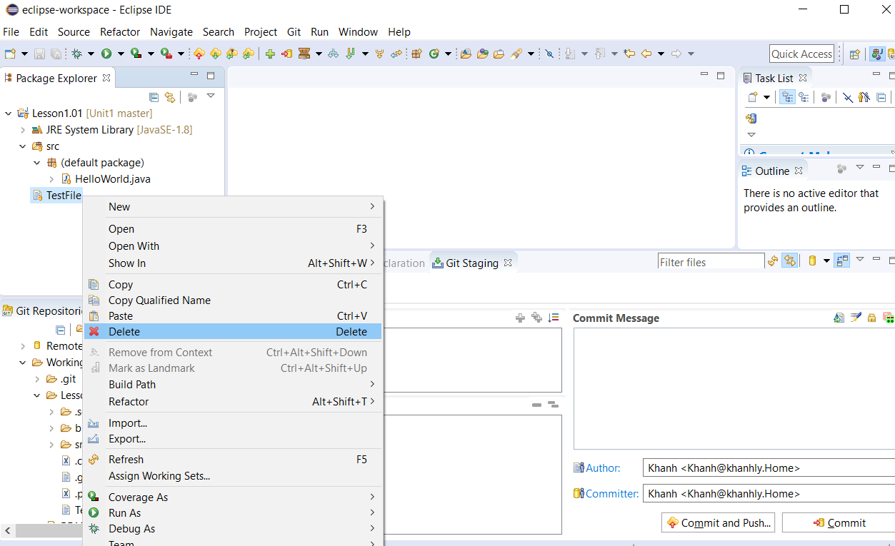

Step 2: Select the OK button

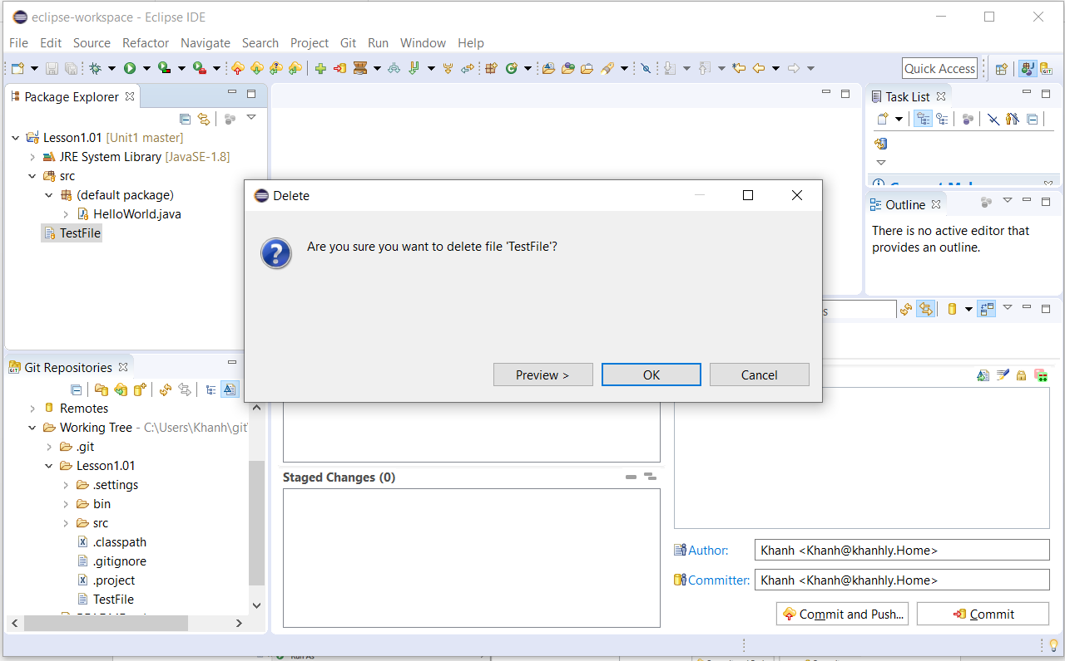

Step 3: Enter some text in the Commit Message box and select the single plus sign icon from the Unstaged Changes section to add the deleted TestFile to the Staged Changes box.

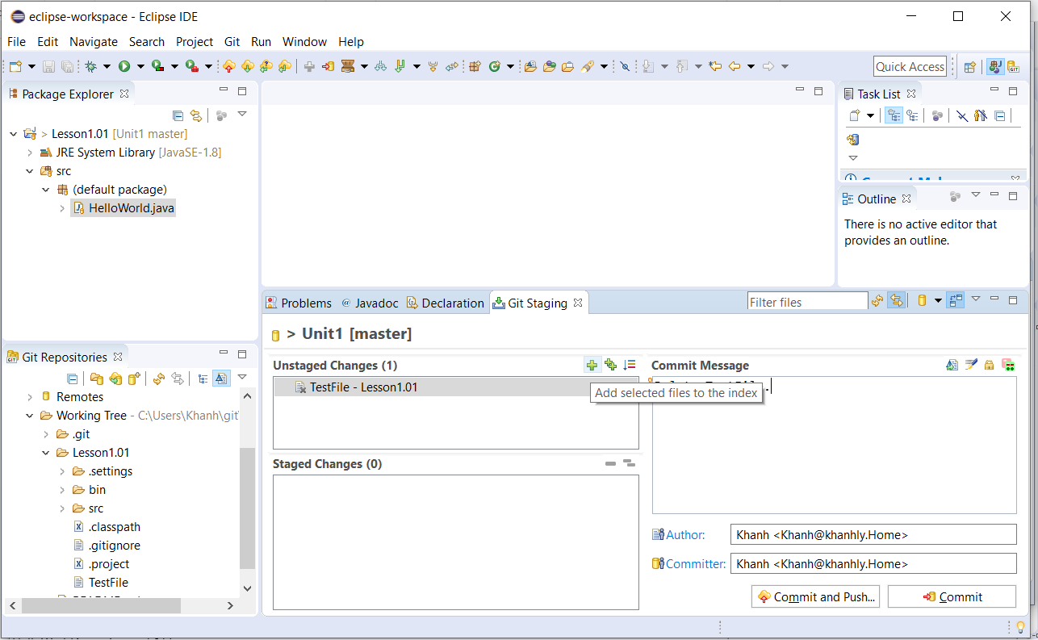

Step 4: Select the “Commit and Push…” button.

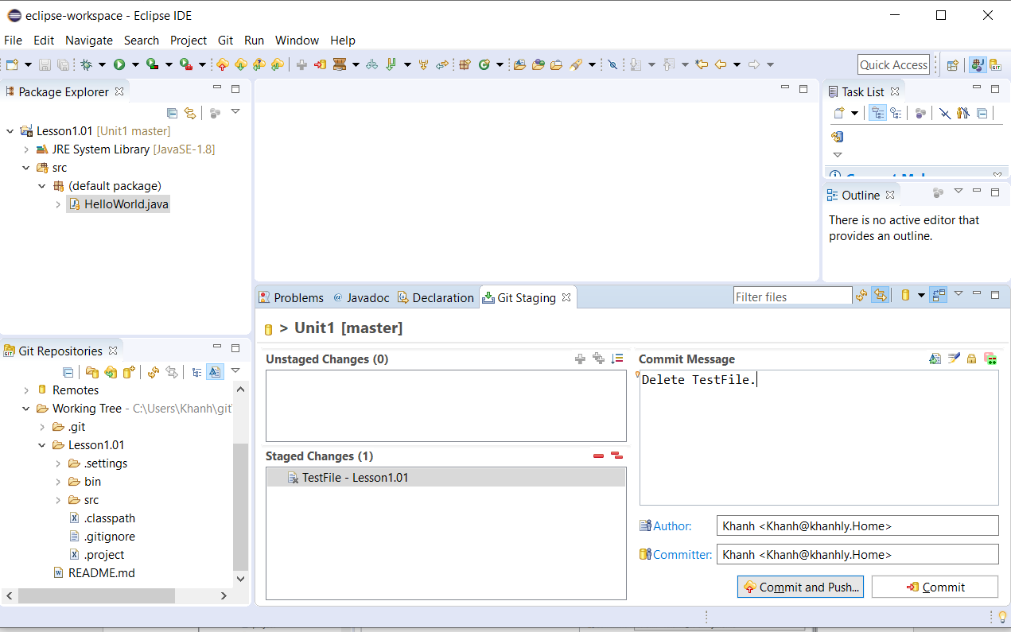

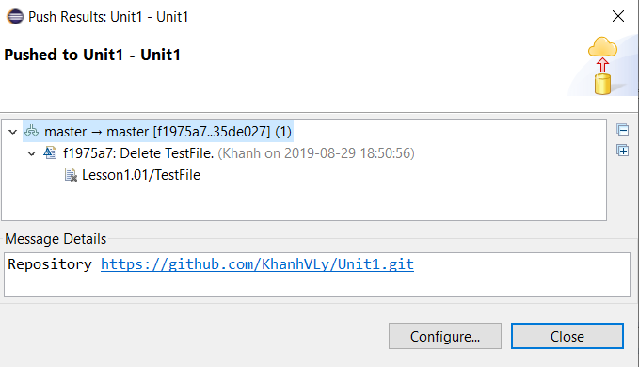

It should look like this.

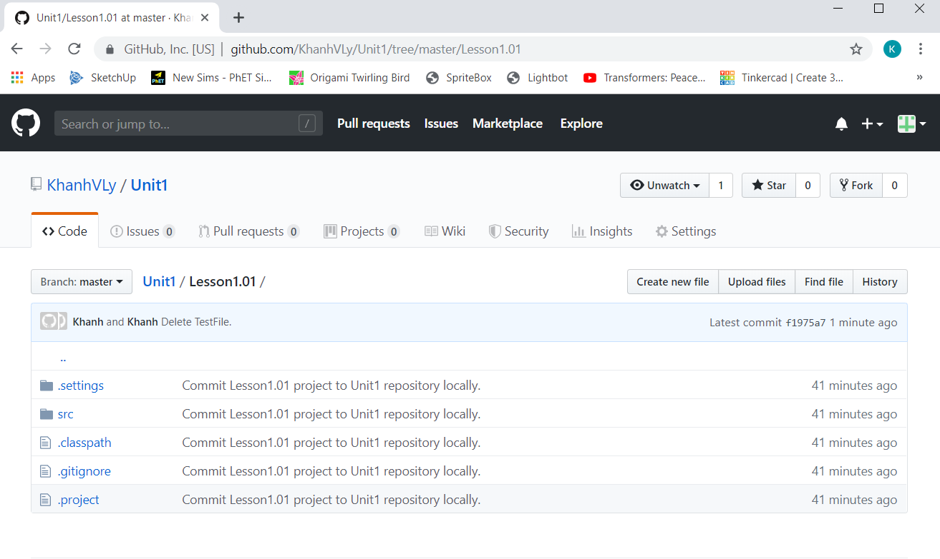

**Edit the HelloWorld.java File from GitHub and Pull it in Eclipse**

Step 1: Navigate to Unit1 repository from GitHub where the HelloWorld.java file is resided and select the pencil icon to edit the file and enter System.out.println("Hello World!"); under the “// TODO Auto-generated method stub” text.

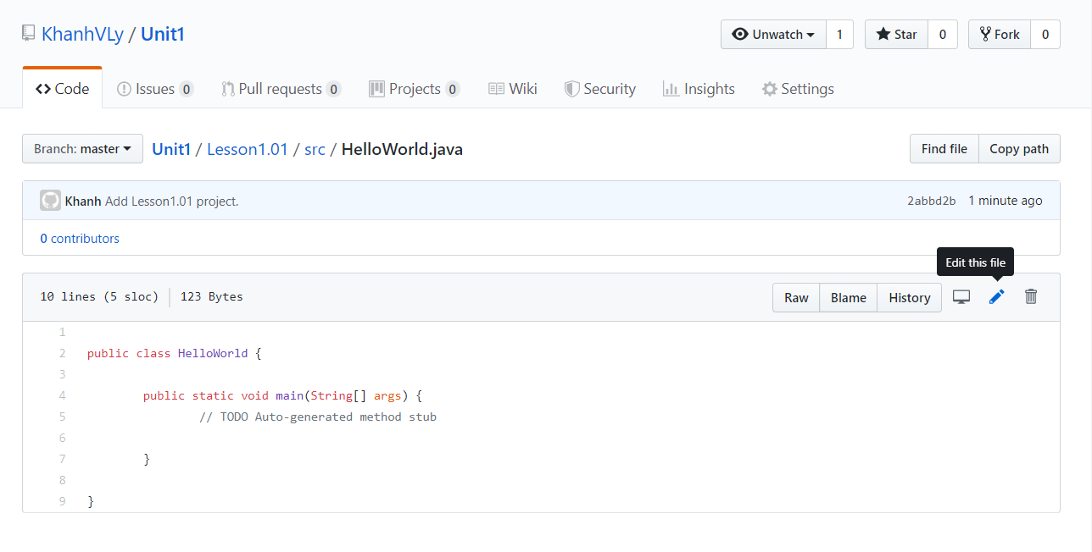

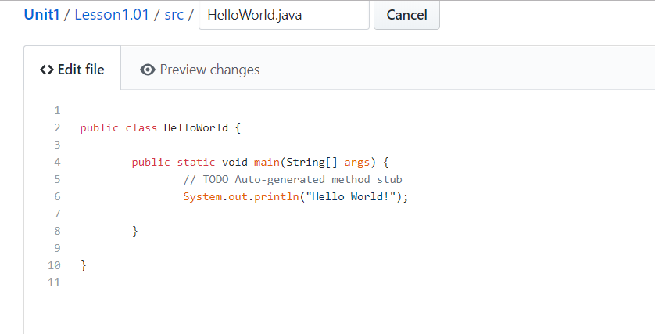

Step 2: Select the Preview changes tab and select Commit and changes button.

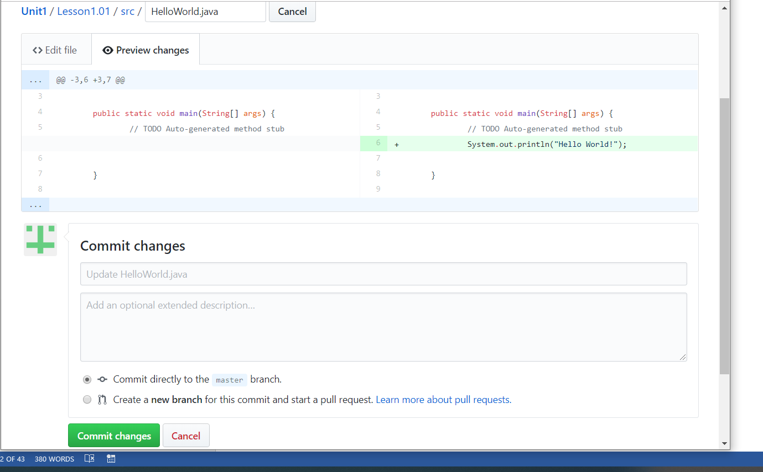

Step 3: Now back to Eclipse and select the icon that has the left arrow and the cloud without the question mark

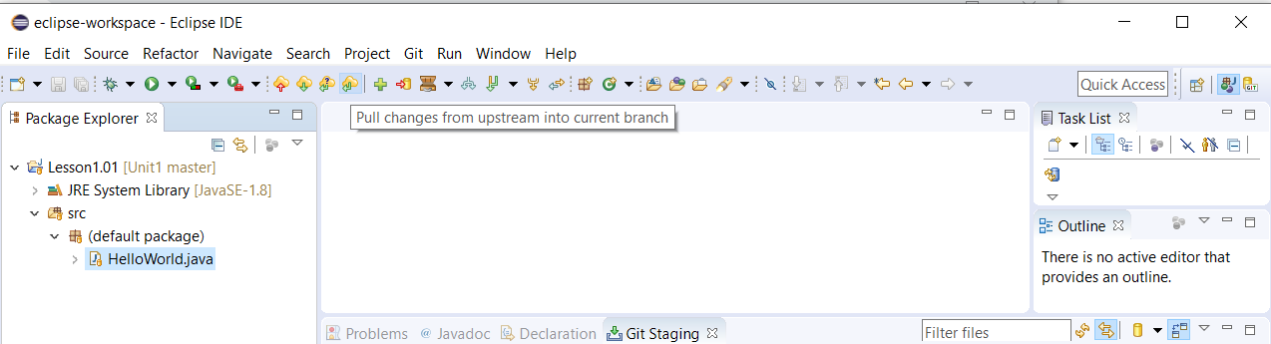

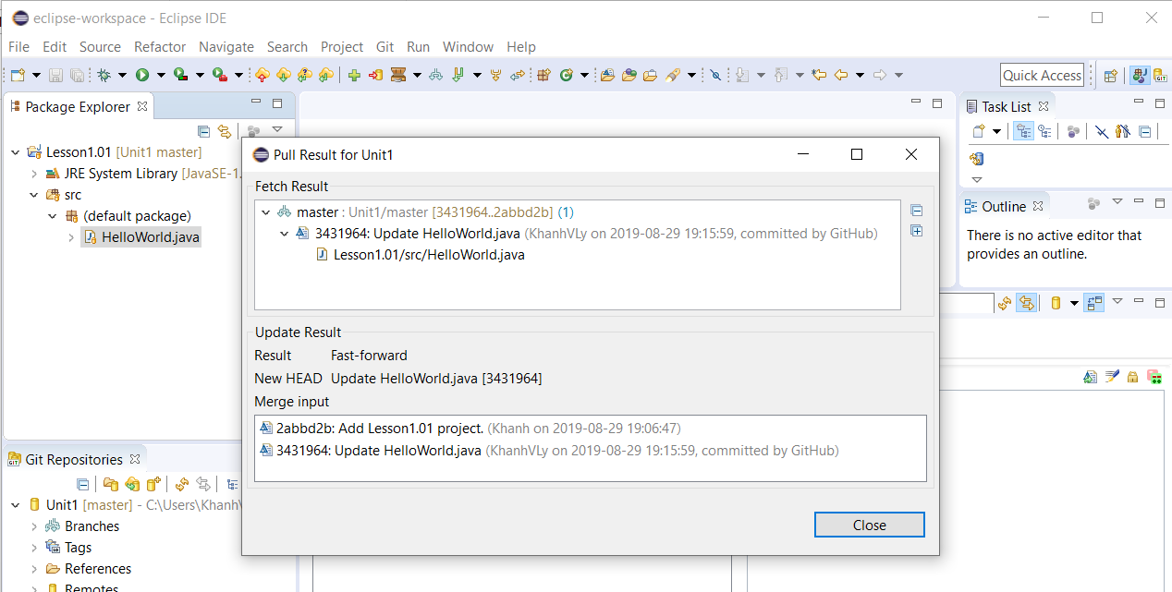

It should look like this.

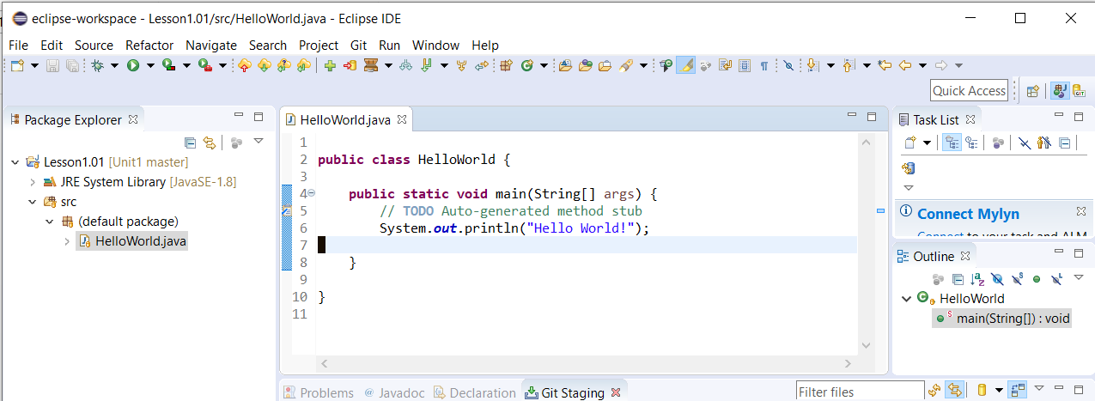

**Add a file in GitHub and pull it down to Lesson1.01 in Eclipse.**

Step 1: Navigate to [Unit1](https://github.com/KhanhVLy/Unit1)/[Lesson1.01](https://github.com/KhanhVLy/Unit1/tree/master/Lesson1.01)/**src**/ from GitHub

Step 2: Select “Create new file” button

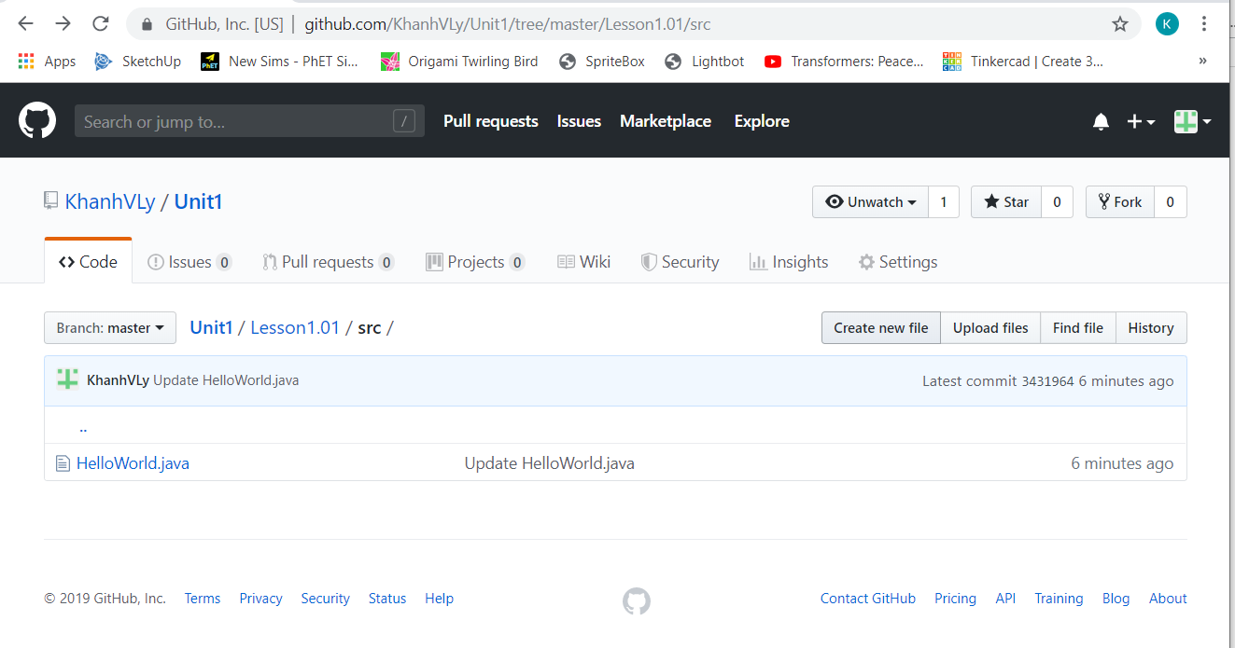

Step 3: Enter “GitHubFile.java” in the textbox next to the Cancel button and enter “This file is created from GitHub.”

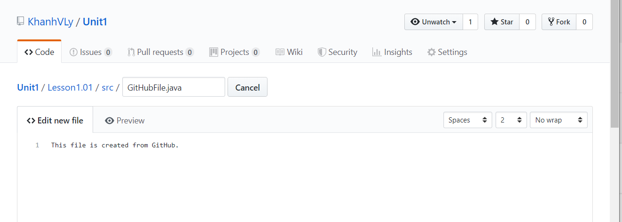

Step 4: Select the Preview button and select the Commit the new file button

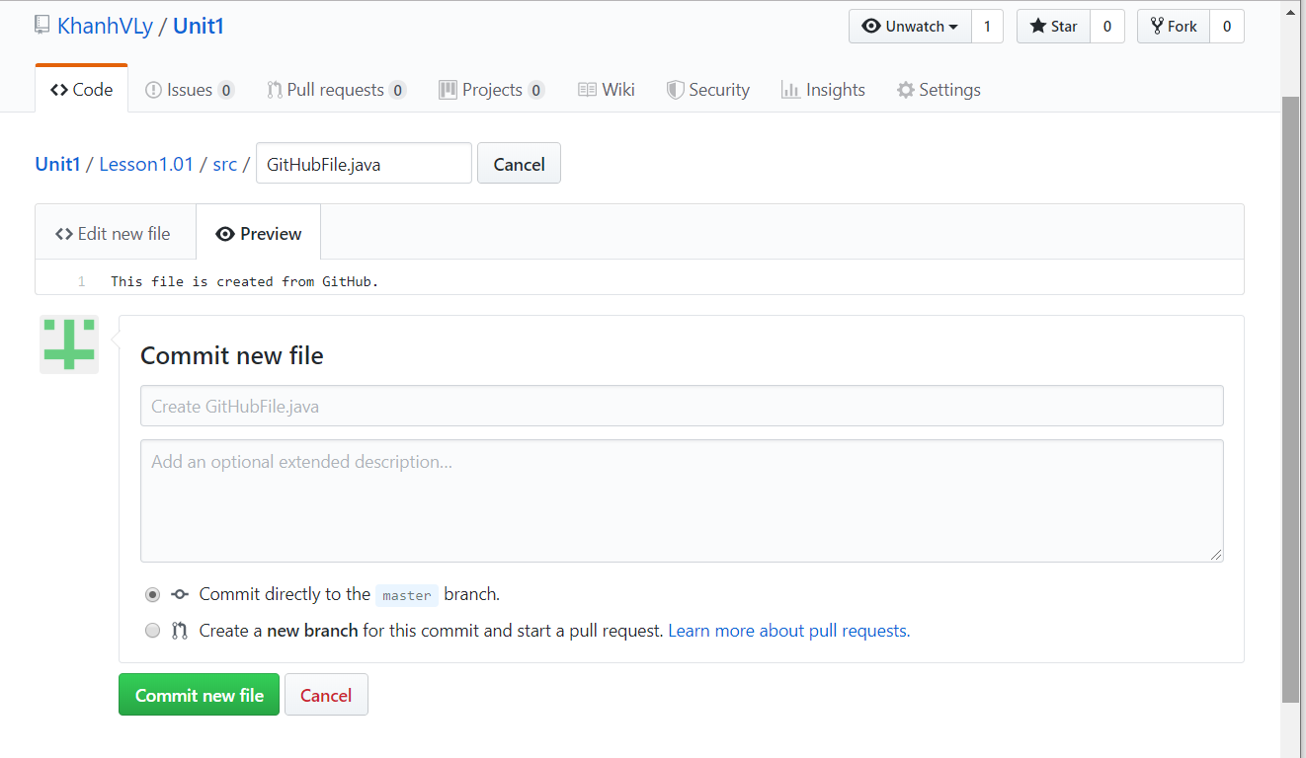

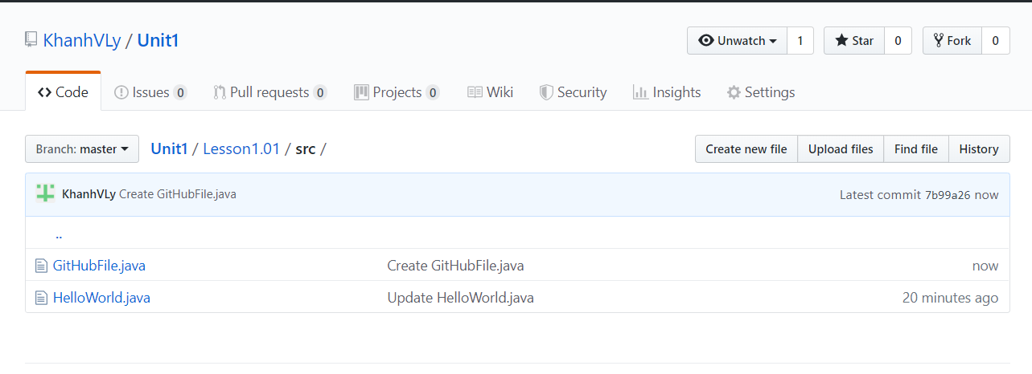

Step 5: Now go back to the Eclipse and pull down the GitHubFile.java from GitHub

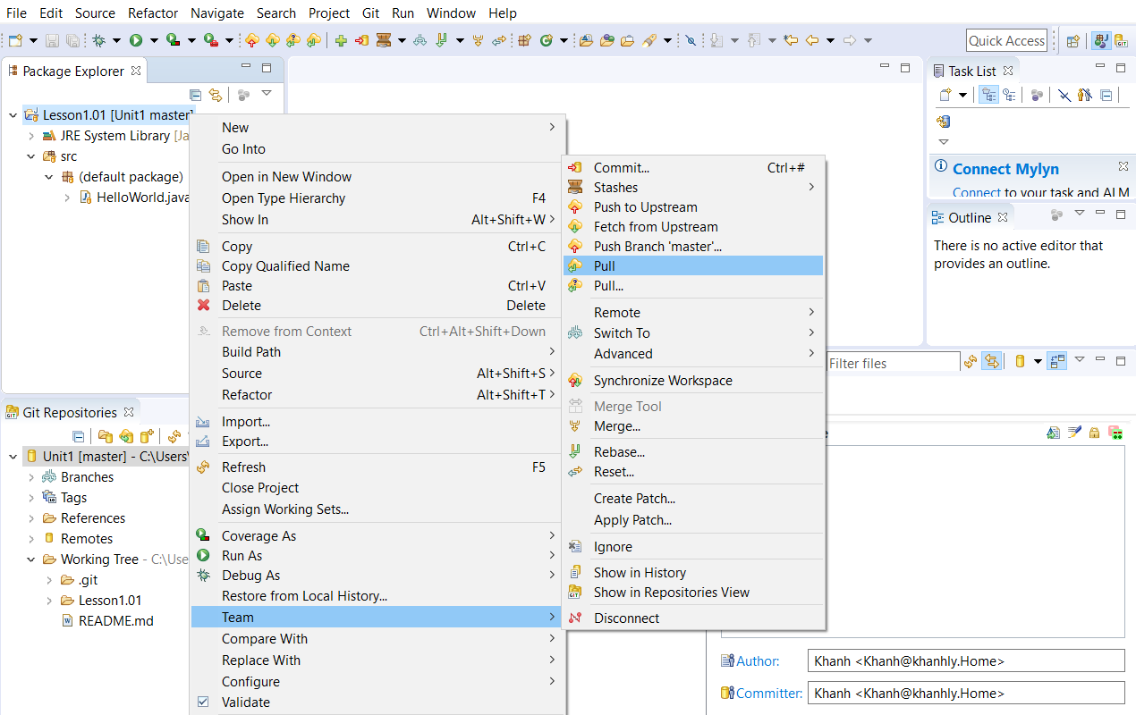

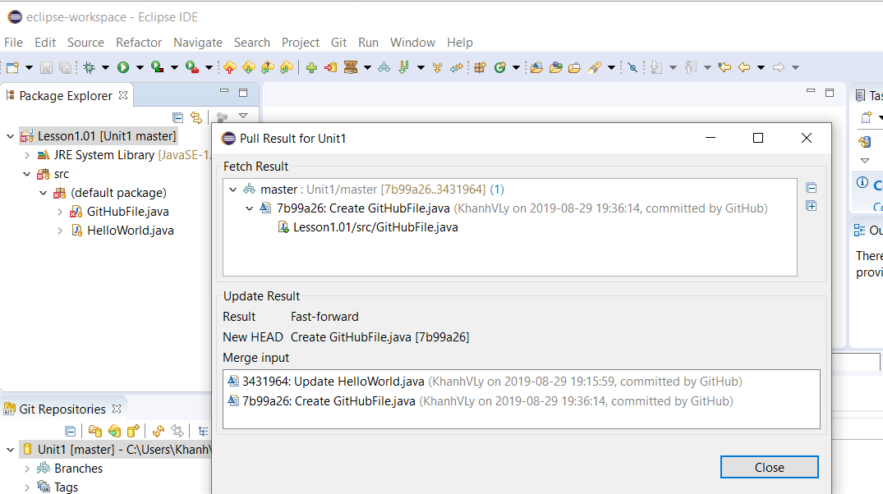

**Import project from GitHub to Eclipse. Note, you don’t have to do this one.**

Step 1: Select the Import projects… link

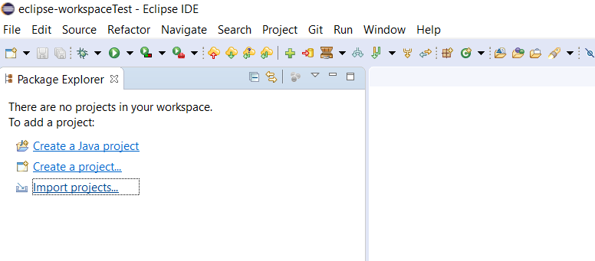

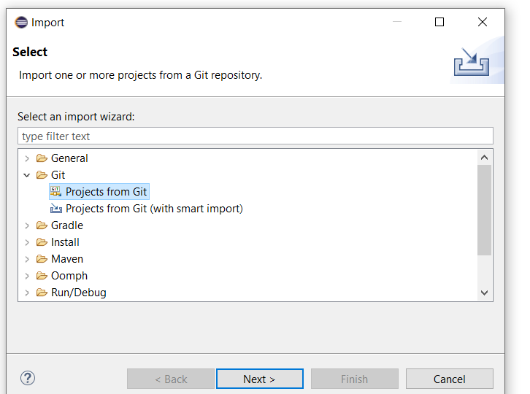

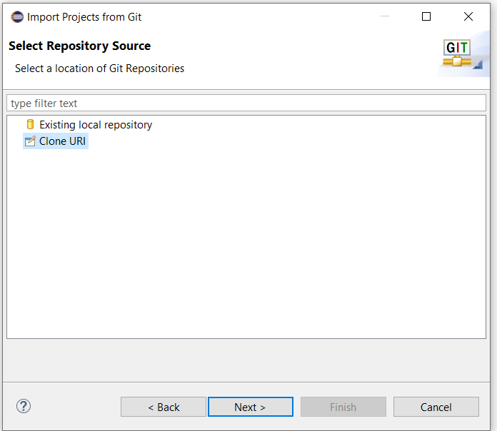

Step 2: Note, this is my info so it should be replaced by your info

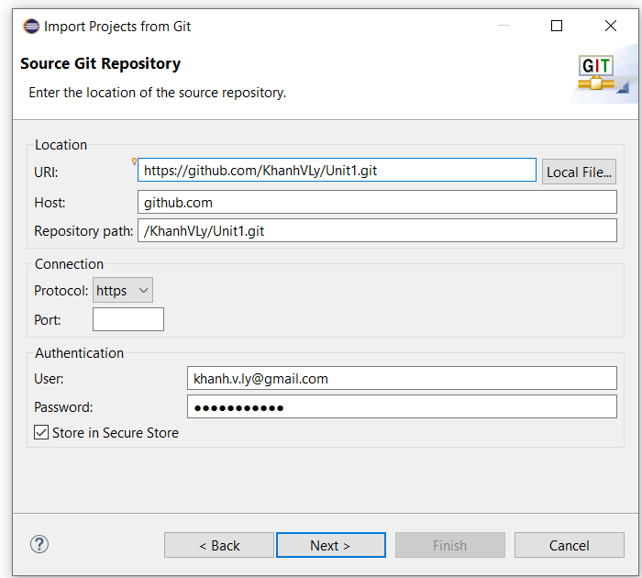

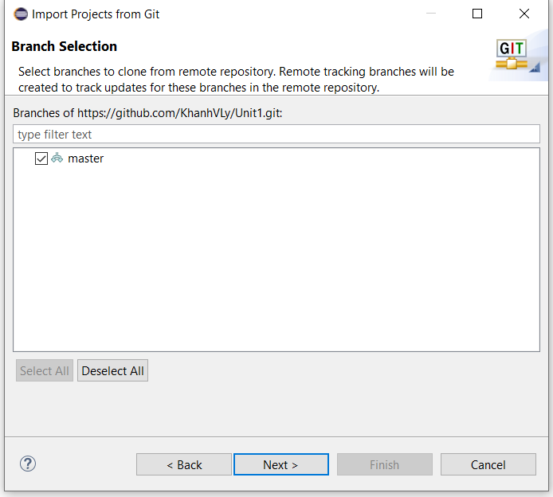

Step 3: Change it to a different directory.

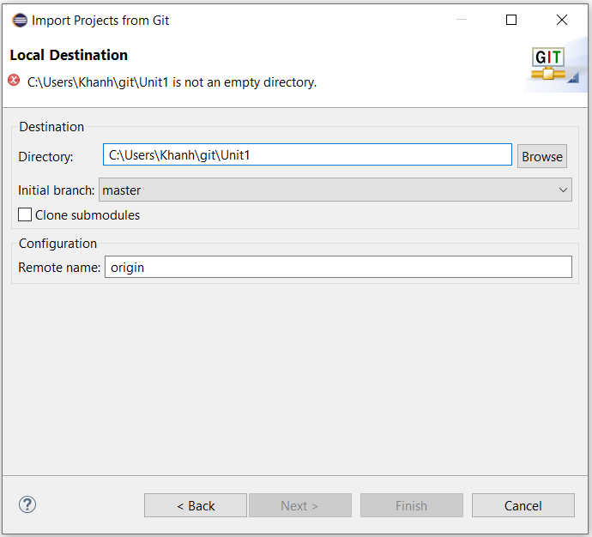

Step 4: Directory changed from step 3.

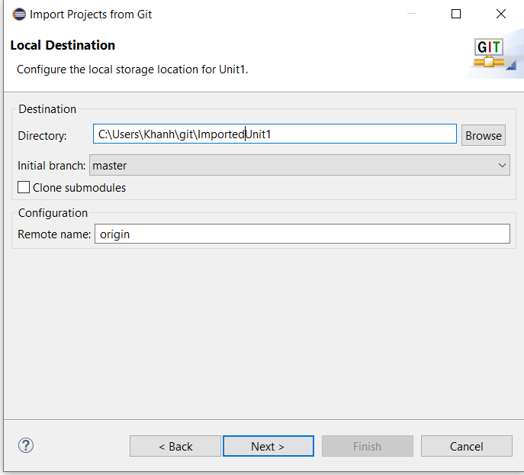

Step 5: Select the Next button then the Finish button.

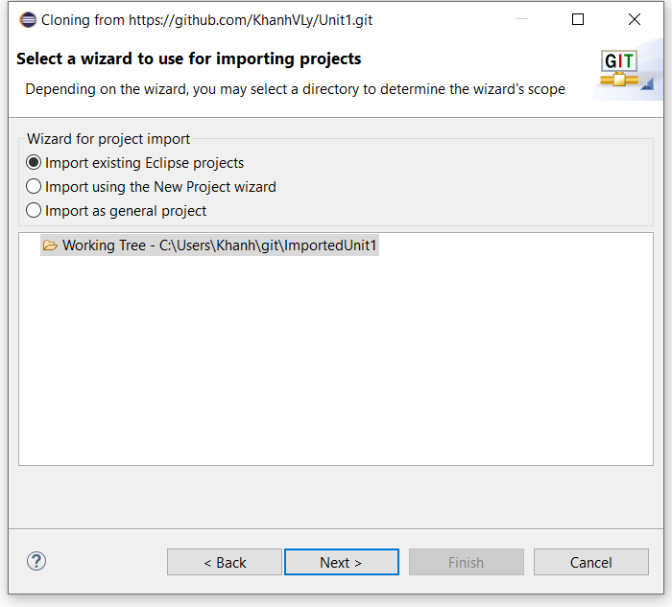

It should look like this.

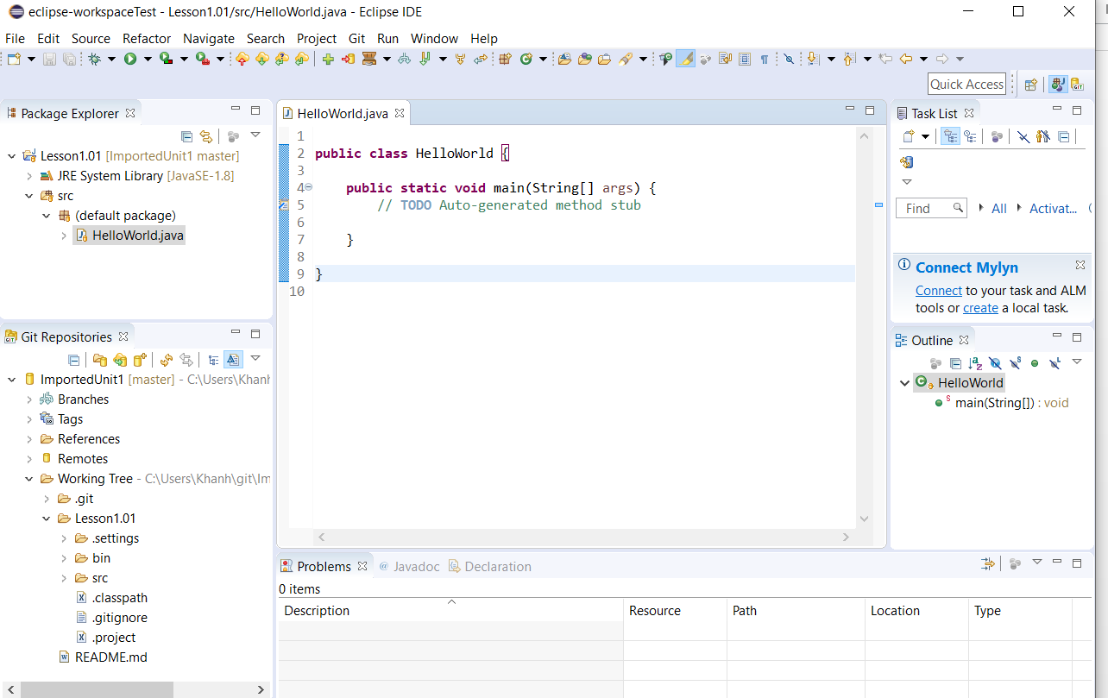

**Delete a Java project from Eclipse and push the deleted Java project to GitHub.**

Step 1: Select Lesson1.01 project and right-click

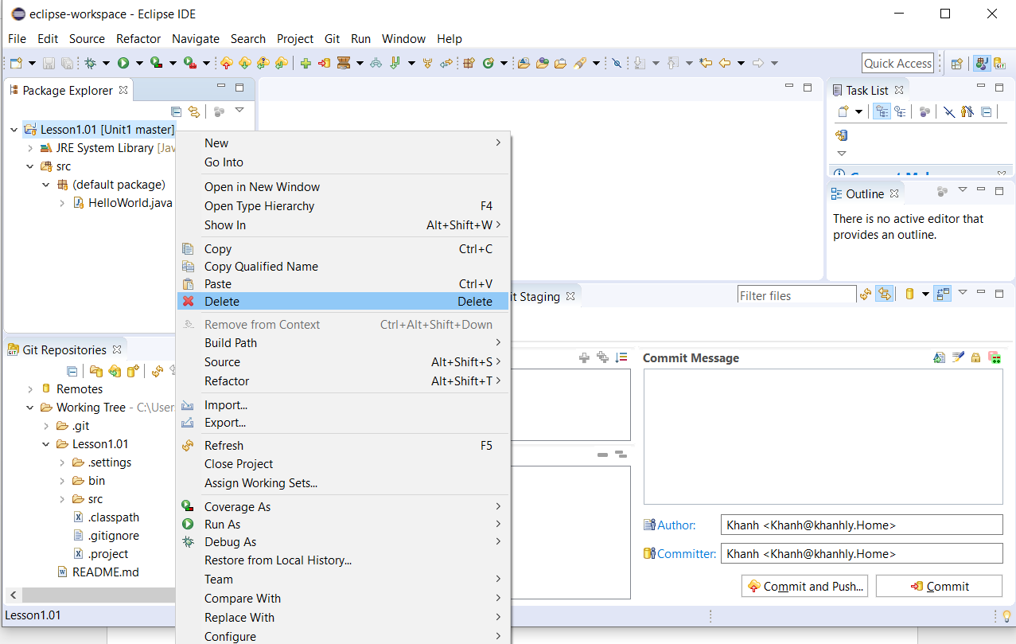

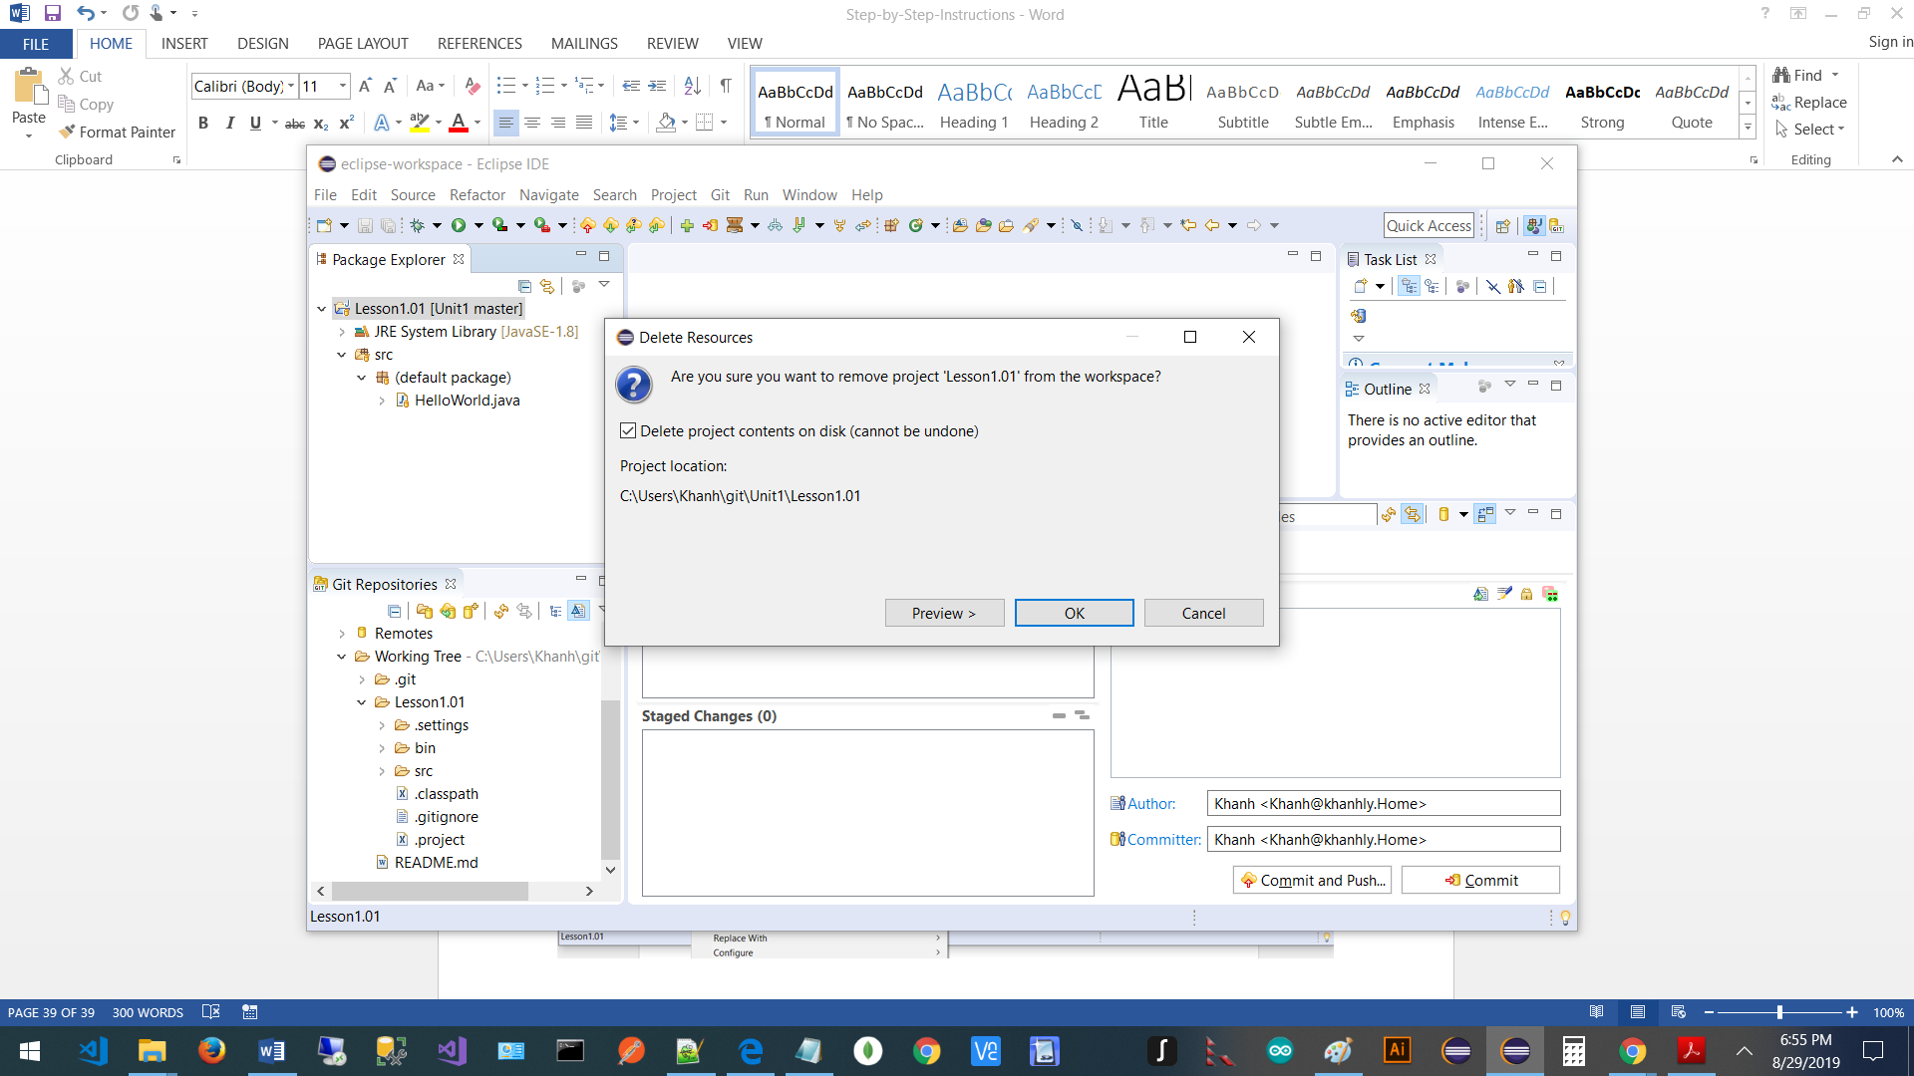

Step 2: Enter some text in the Commit and Message box and select the double plus sign icon from the Unstaged Changes section to add all the files and folders to the Staged Changes box.

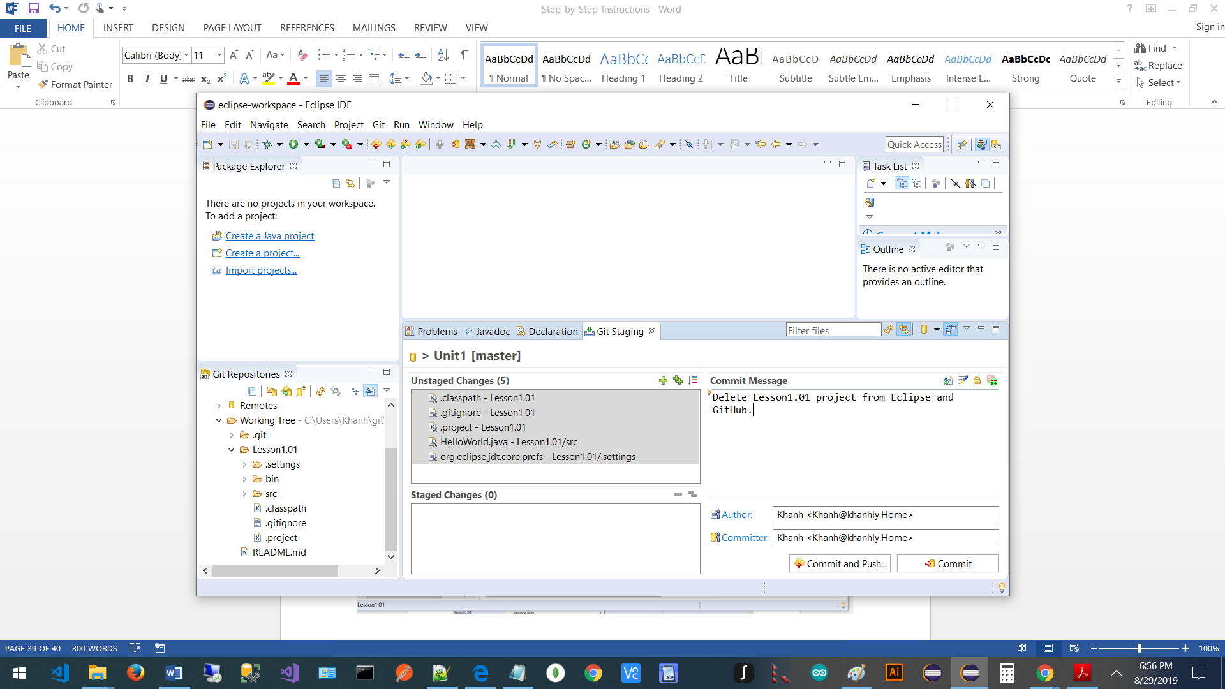

Step 3: Select the Commit and Push… button.

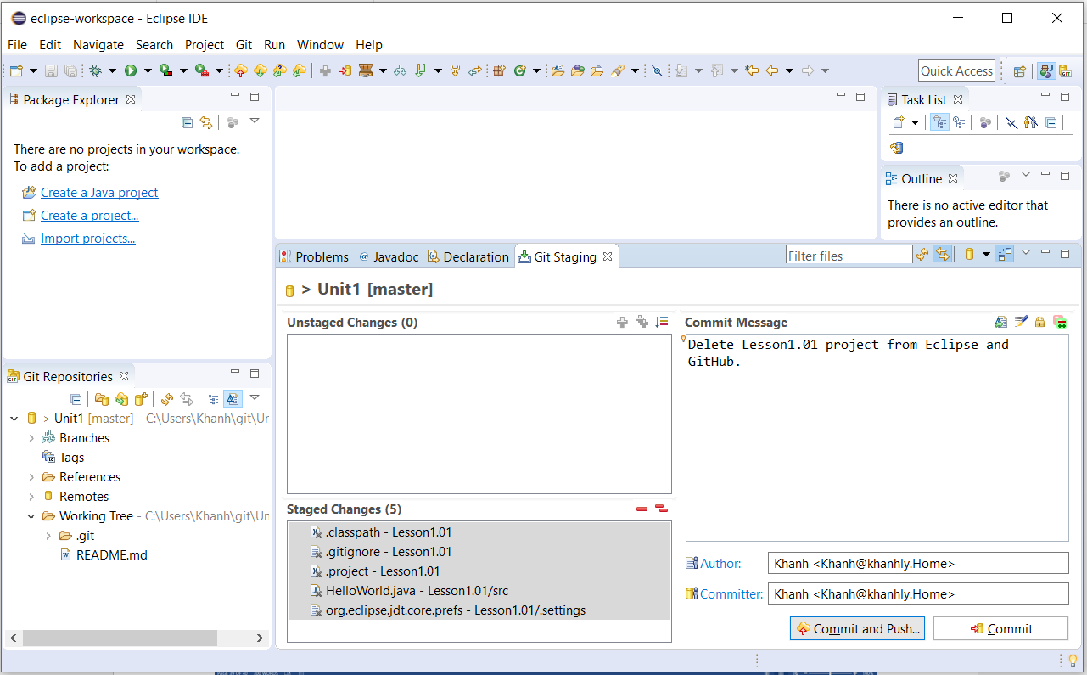

It should look like this.

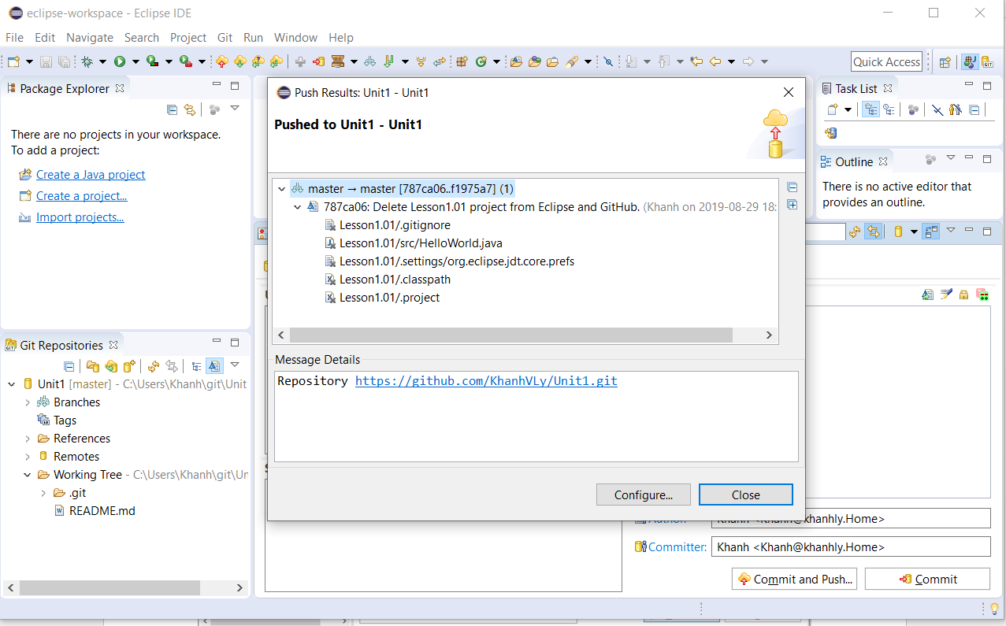

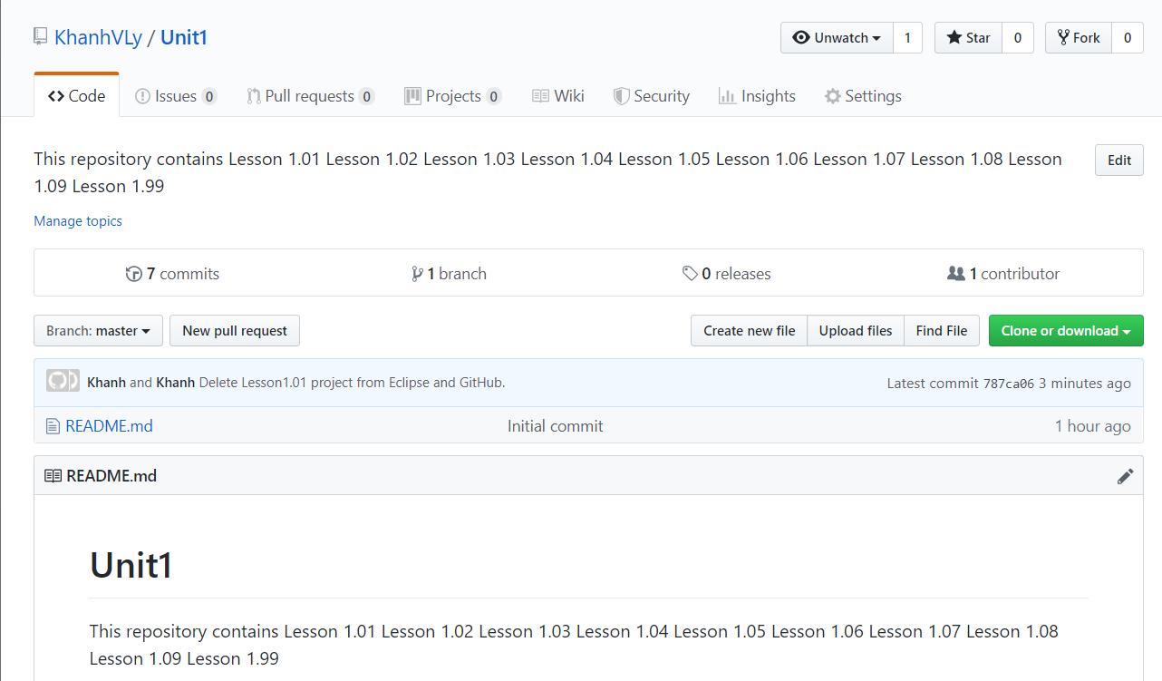

**Delete a repository from GitHub**

Step 1: Select Unit1 from GitHub and select the Settings next to the gear icon and scroll all the way to the bottom and select Delete this repository button

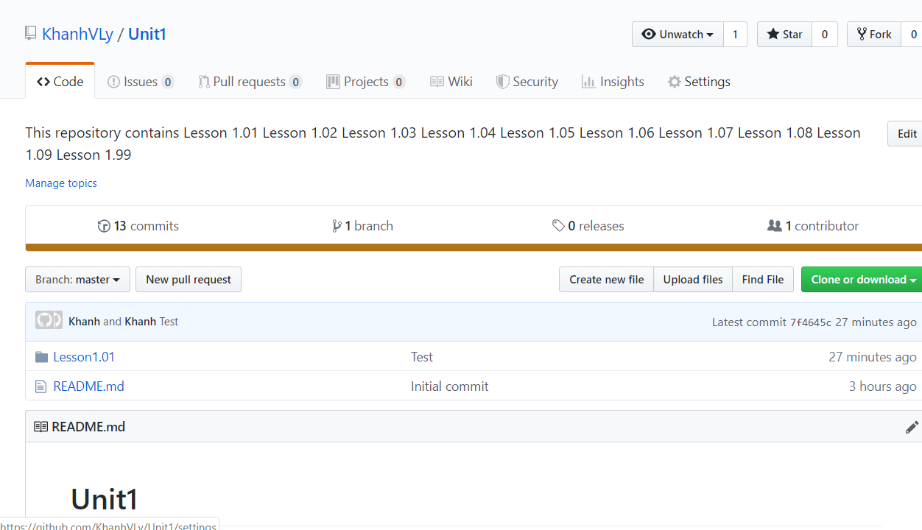

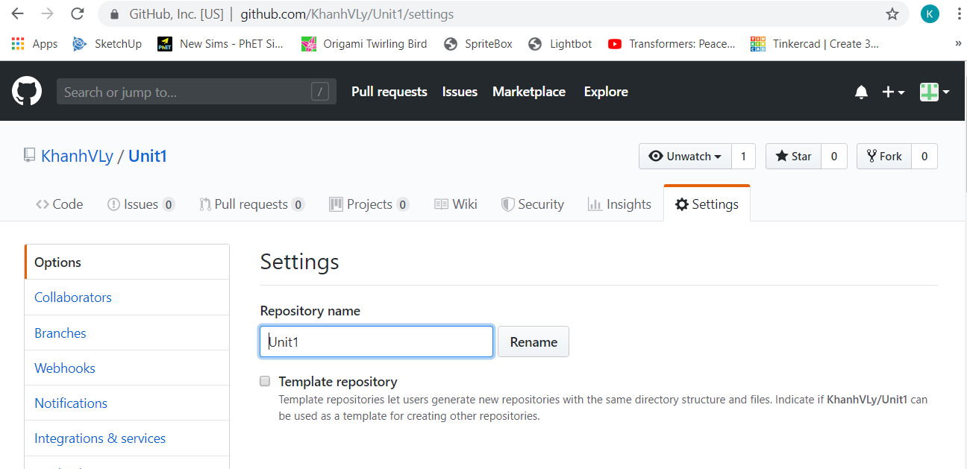

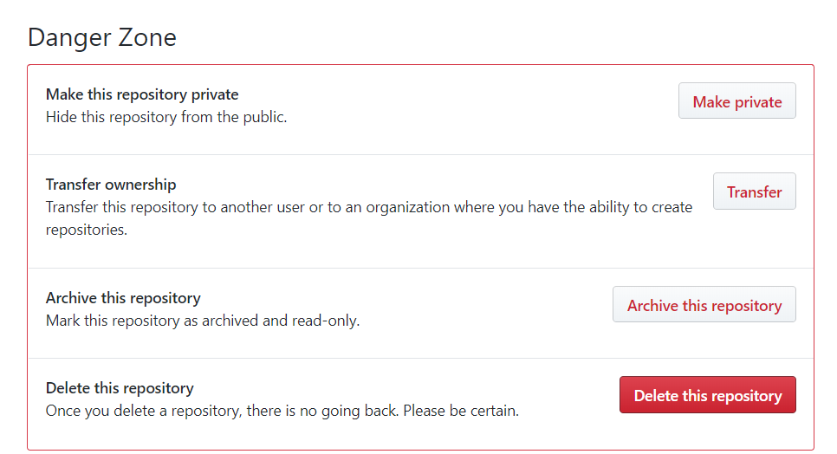

Step 2: Enter the repository name and select the “I understand the consequences, delete this repository” button

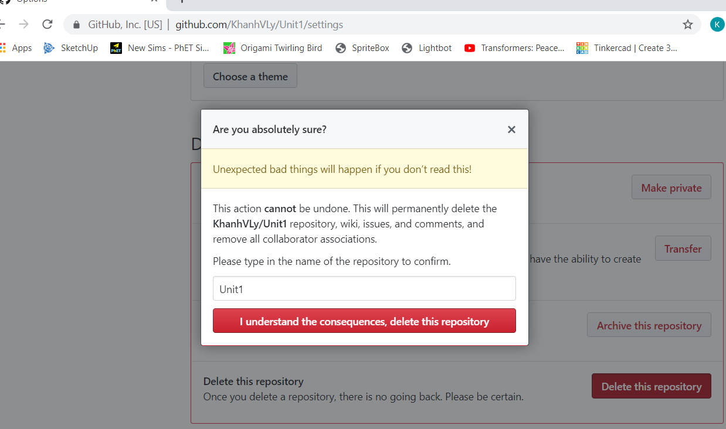

Step 3: Enter your password

